The Official Publication of ALUA—An International Association or security r-roressionais

March 2006

ACCESS

CONTROL

Today’s Locking Systems are  
Evolving in Sophistication.

PLUS!

Trailer Tough

Sargent & Greenleaf’s Biometric Kegpad Customer Appreciation **Daze** and More!

*********AUTO**SCH 3-DIGFT 303

Stephen L. Gebbia CML

Security Engineering Consultants, Inc.

PO Box 48088 Atlanta GA 30362-1088

l..llilli.i.ill.illmil.l.i.lllli..l.il.l.il.l..l.liil...llil

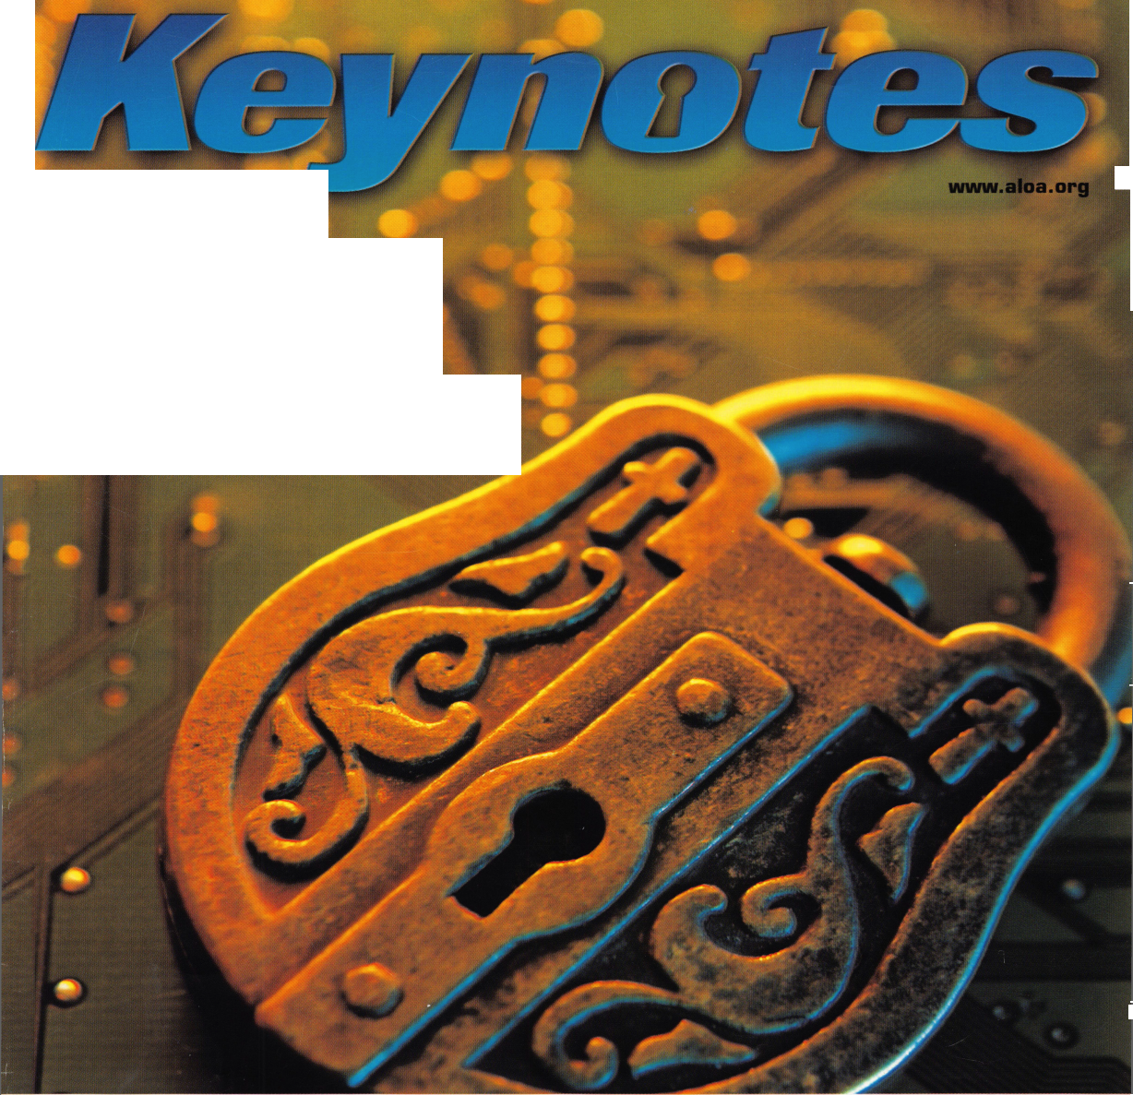

**OUR STAND**

IT’S QUITE POSSIBLY YOUR MOST

**TRUSTED SIDEKICK.**

You’re in good hands.

**Keep it in Good Hands® with Allstate.**

As a small business owner, there are few things you rely on more than your vehicle to keep you going. Your local Allstate agent can help protect it and your small business with services you need including

quick certificates of insurance, ID cards, assistance with the claims process, and more. All from one of the most widely recognized names in the business.

Are you in Good Hands®?

**irstate Indemnity Company, Northbrook, IL, Allstate County Mutual Insurance Company, Irving, TX. A I state New Jersey Insurance Lered service mark and "Our Stand7' is a service mark of Allstate Insurance Company. ©2005 Allstate Insurance Company, Northbrook, IL.**

1-800-859-0247

CALL NOW TO LOCATE YOUR NEARBY ALLSTATE AGENT.

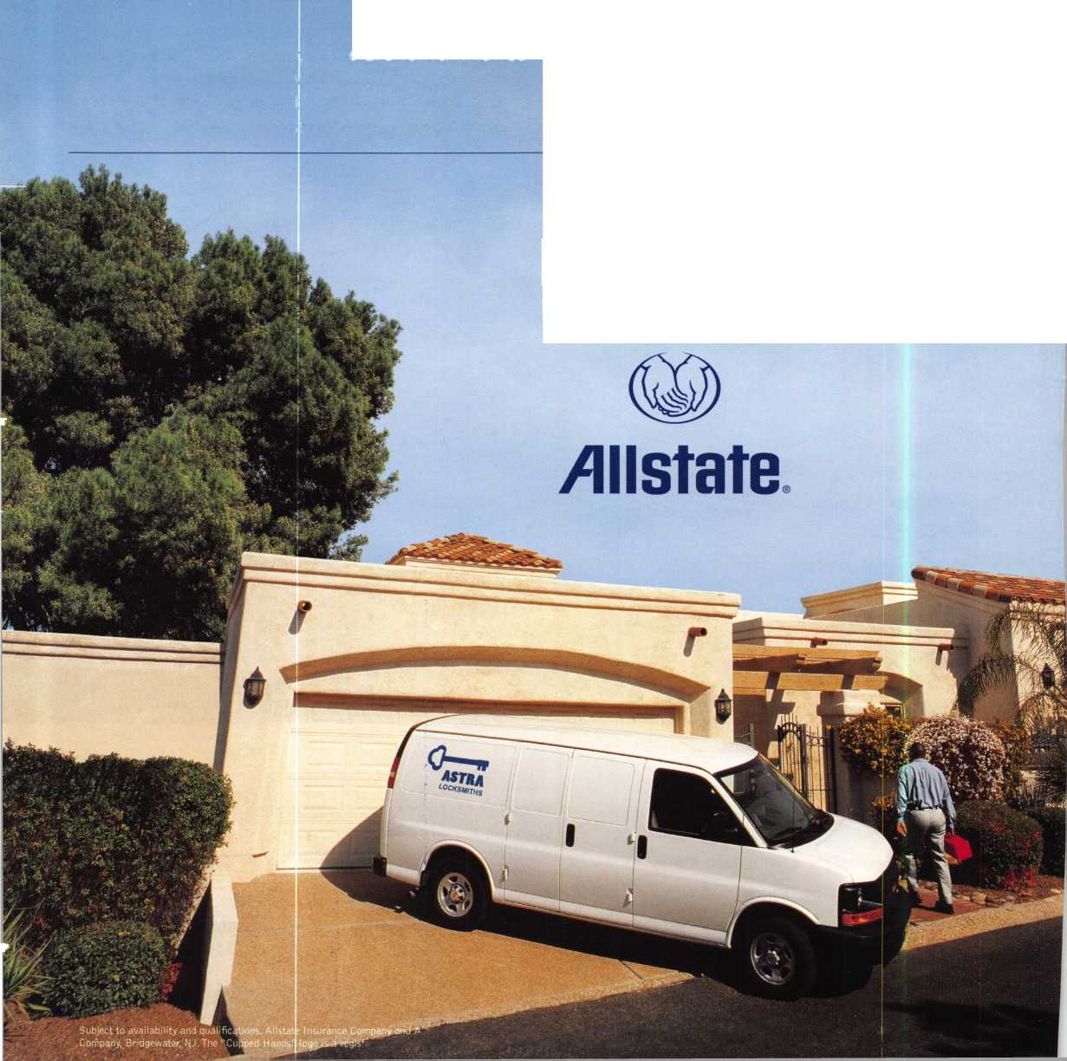

A Name You Know

As a business owner, you know the importance of a good name. Your name is your reputation. Your name stands for all that you offer in products and services. It’s a symbol of who you are. So, we thought you might like to know that Allstate, the name you know for insuring your personal vehicle and your home, also offers a business auto policy to help protect vehi­cles used in your locksmith business.

The following are coverages typically included in our business auto policy that might be important to you as a business owner:

Business Auto Liability coverage

* Higher limits up to $2,000,000 per occur­rence.
* Protects you if you are legally responsible for injuries and damages arising out of the ownership, maintenance, or use of business vehicles.
* Cost is based on several factors, including garage location, type and use of vehicle, and the violation and accident activity of your drivers.
* Additional Insured coverage may be required when you contract with govern­mental agencies or bid on local commercial jobs.
* Generally not available on a personal auto policy.
* Usually is no charge to add an insured to a Commercial Auto policy.

Hired Auto coverage

* Provides liability coverage for those vehicles you rent, hire or borrow for business use.
* The premium for hired auto liability coverage is based on the estimated annual rental cost.
* Tools and Special Equipment
* Provides protection to permanently attached equipment on your vehicle.
* You will need to let your agent know the value of the equipment to include in the cost of the vehicle.

You’re good at your business. Your insurance com­pany should be the same way.

Contact an Allstate agent to discuss your business auto insurance needs. To be referred to an agent, please call 800.859.0247 or email [abisO@allstate.com](mailto:abisO@allstate.com).

Subject to availability and qualifications. Insurance coverage is subject to policy terms.

Allstate Insurance Company

Allstate Indemnity Company Northbrook, IL

Allstate County Mutual Insurance Company Irving, TX

Allstate New Jersey Insurance Company Bridgewater, NJ

allstate.com

© 2005 Allstate Insurance Company, Northbrook, IL



Need information in a hurryP  
Use AIMs Fax On Demand service.

Just call 310-575-5074 and receive: 13. Safe & Vault Technicians Association Member

|  |  |  |  |
| --- | --- | --- | --- |
| 1. | ALOA Index of Documents |  | Application/Subscription Form (2pg) |
| 2. | Becoming a Locksmith (lpg) | m | ALOA Chapter Roster (3pg) |
| 3. | Locksmith Career Summary (3pg) | 15. | Legislative Action Network (2pg) |
| 4. | Locksmith School List (2pg) | 16. | Legislative Action Network Newsletters (lpg) |
| 5. | ACE Class Schedule (8pg) | 17. | Various State Laws(lOpg) |
| 6. | Certification lnformation(3pg) | 18. | Industry Position Pager (lpg) |
| 7. | PRP Category List (lpg) | 19. | Current Legislative Action Network |
| 8. | ALOA Membership Application(2pg) |  | Newsletters (lpg) |
| 9. | ALOA List of Benefits (lpg) | 20. | Board of Directors Nomination Form (2pg) |
| 10. | Scholarship Application Form (lpg) | 21. | ALOA Convention Registration |
| 11. | ALOA Video Library Order Form (lpg) | 22. | ALOA Board Expense Reimbursement & |
| 12. | ALOA Membership Items Order Form (lpg) |  | Request Form |

ALOA continues to provide you with this and other great benefits and services!

310-515-5014

**Your Finger is THf** Ki  
**Fingerprint Access Systems  
Standalone & Network**

<

V)

D

>

Q)

J*

0)

■

5

5

5

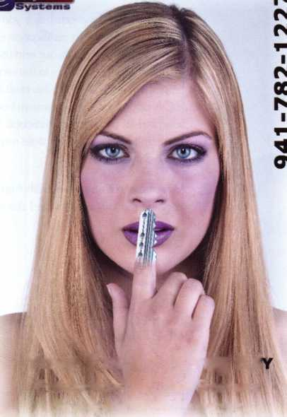

|  |  |  |  |
| --- | --- | --- | --- |
| p r e s i d | e n 1 | t i a | 1 |
| view | p o i | n t |  |

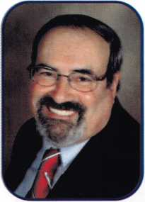

Dear Members,

March not only blows in like a lion, but along comes all those great locksmith conventions and classes. I will have had attended SAFETECH 2006, SAVTA's convention in Albuquerque, New Mexico. Ill have been there starting March 3rd. In fact, the entire ALOA Board of Directors was in attendance as we held our annual spring board meeting at the end of the convention. One of the very important items, of many, up for discussion was our website and its vital role in attaining our associations ends. We find that it is very helpful to our membership to hold our meeting over a locksmith event. In this way we become more available to the membership. I hope you spotted one of us and came over to express any of your concerns or just to say, "Hi". We were those handsome guys wearing black ALOA board shirts.

For those of you in the Northeast, comes a very special event. The Master Locksmiths of New Jersey is celebrating their 75th anniversary at their convention in Secaucus, New Jersey. Ill be there beginning Friday evening, March 17th along with a few of the above mentioned guys. If you have an extra minute or two, consider visiting with us. Along with super classes and exhibit, don't forget to sign up for the banquet. Its having fun while you learn and share with your colleagues seventy-five years, what a wealth of knowledge for a bright future!

As March goes out like a lamb. I'll be out of country attending the European Locksmiths Federation's Convention. Starting April 5th, I will be in Venice, Italy. It is amazing how much can be learned by attending a convention out of the United States. Our industry is global. Our thinking and our actions should reflect the n€jed for knowledge from all sources if we wish to succeed.

Conventions and association meetings are a terrific educational resource. Your attendance at these events can only further your professional career. I learn at least one new thing at every event. With the number of meetings and events I attend, you would think I would be the brightest guy around, but in truth, this industry has such a plethora of collective knowledge, it would take more than two lifetimes to absorb it all. Its all out there waiting for you learn.

Attending these functions helps you with your recertification, as does being an active member of an association. In the near future, with certification and recertification in place along with background checks, our association will have a tangible value to our end users. By all of our members attaining a level of proficiency with continued edu­cation ensures us to be up to the requirements of the new licensing laws that are being put in place by so many of the states in the USA. With this push to become a better and more qualified security specialist comes benefits. When ALOA approaches a government agency, the insurance industry or the automotive industry to have our members accepted as certified professionals to perform services, we can point with pride and confidence to the quality of our membership. When a state requires standards to obtain a license, those standards are already a rule for our membership.

As we celebrate our own 50th Anniversary, let us start our journey to our 75th and hopefully our 100th. Let us all work to maintain our elevated status a premier security association.

Take 'er easy!

Sincerely,



Robert E. Mock

Keynotes • March 2006

CAL-ROYAL

an

**jiicksoii**

**tecuritv**

LCN

**MONARCH**

NORTON

./Parker

***RE\AUTOMOTIVE*** r ***Jet***

« BtRAHD A1 lockcraft^ ASP HATA

***DETERMINATOR MAJOR (fggigt***

#

PRQ-LOK

^ STRATTEC gcTT^

SCHLAGEI

VON DUPRIN

**ET -aS**

*roots*

*\*’ OEMMID M*

**A AfM-f:**

**0ASP**

AVENGER

r J f . : .r ;v;r *r



**LOCKCRATT%**

**0 Ah)**

**loCK** 1**ECHNOLOGY\***

*MAJOR*

PROHLOK

*(jRytzm*

*Sieveking*

mSTRATTEC

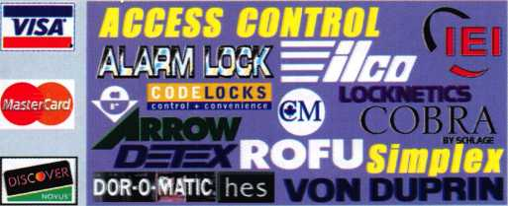

***Why Do  
Locksmiths  
Everywhere Buy  
Supplies at  
H.L.FIake?***

*He Extremely Competitive  
He E/Z Free Freight Minimums  
He Same Day Shipping* J _

*He Service with a Smile  
He High Fill Rate  
He Hard to Find Items*

*He E/Z Order Web Site*

*[WWW.HLFLaKE.com](http://WWW.HLFLaKE.com)*

* ***Order*** *24* ***hours a day***
* ***Updated Every Business Day***
* ***Extra Discount for Web Orders***
* ***Personalized Inventory Lists***

*LOG ON TO...mmm* __ _ ___

[www.HiruKE.com](http://www.HiruKE.com)



»&6C0



**feat**

ACCESS CONTROL 2006

10

Computer-managed Locks

Computer-managed locking systems are the new workhors­es of the lock industry. Find out why!

20

**25**

Trailer Tough

Greg Perry discovers why some customers are easy, others demanding, and some a combination of both.

by Greg Perry, CML, CPS

Kaba llco on Modern Marvels TV!

Find out what happened when the film crew of the Modern Marvels tv series visited Kaba llco.

**26**

Sargent & Greenleaf's Biometric Keypad

Check out how S&G's new high-tech locking system can work for you.

by Brian Cosfiey, CML, CMST

**32**

Customer Appreciation **Daze**

Claire Cohen thanks you and also reveals how you can show appreciation to your customers.

by Claire L. Cohen, CML

u r e

s

|  |  |
| --- | --- |
| r | 1 |
| AD INDEX | |
| Allstate | ..Inside Front Cover |
| Fax on Demand | 1 |
| E-Key | 1 |
| HL Flake | 3 |
| Safetech 2006 | 7 |
| IR | 13 |
| Service Magic | 15 |
| ALOA 2006 | 19 |
| Doorking | 21 |
| A&B Safe | 23 |
| Clearstar | 24 |
| CCL | 27 |
| ALOA Member Recruitment. | 31 |
| SafeData | 34 |
| President's Club | 35 |
| PBP | 42 |
| Payment Retriever | 42 |
| Turn 10 | 42 |
| Strattec | 43 |
| MLANJ | 44 |
| CompX | Inside Back Cover |
| FKI | Back Cover |
| L | j |

**Departments**

|  |  |  |  |  |  |  |  |  |  |
| --- | --- | --- | --- | --- | --- | --- | --- | --- | --- |
| Presidential |  | Exec | utive | 5 | Calendar | 8 | Classified | 36 | Legislative 40 |
| Viewpoint | 2 | App | icants .... | 6 | Core | 9 | Associate Members | 38 |  |

Visit our NEW website at [www.aloa.org](http://www.aloa.org)

i

**executive**

Volume 52, Issue 3

Additional contact information for the ALOA Board and most Keynotes authors is  
available through "Locksmith Search'" on the ALOA Web site- [www.aloa.org](http://www.aloa.org) or by  
contacting the ALOA office at 3500 Easy Street; Dallas, TX 75247; (800)532-2562;

FAX (214)819-9736; e-mail [aloa@aloa.org](mailto:aloa@aloa.org).

Editor

Betty Henderson [betty@aloa.org](mailto:betty@aloa.org)

Advertising Sales

Kim Hammond voice: 817-645-6778

Fax: 817-645-7599 e-mail: [adsales@aloa.org](mailto:adsales@aloa.org)

Executive Director

Charles W. Gibson, Jr., CAE [charlie@aloa.org](mailto:charlie@aloa.org)

Associate Executive Director

David Lowell, CML, CMST [david@aloa.org](mailto:david@aloa.org)

Convention & Meetings Manager

Jo Anne Mims [joanne@aloa.org](mailto:joanne@aloa.org)

Operations/Membership Manager

Mary May [mary@aloa.org](mailto:mary@aloa.org)

Director of Creative Services

Betty Henderson [betty@aloa.org](mailto:betty@aloa.org)

IT Operations Manager

Greg Jackson [greg@aloa.org](mailto:greg@aloa.org)

Comptroller Kathy J. Romo

Membership Coordinator Shelly Jett

Convention & Meetings Assistant Karen Lyons

PRP/Education Coordinator Mayra Ocon

Mail Room Coordinator Kevin Wesley

Creative Media Specialist Margarita Garza

Accounting Coordinator Joyce Nixon

Executive Assistant Sue Langford

Assistant Education Manager Bob Stafford

Legislation Manager Tim McMullen

Receptionist Shelley Molton

Contributors

Jerome Andrews, CML  
Paul Chandler, CRL  
Claire Cohen, CML  
Brian Costley, CML, CMST  
Eric Costley, CRL

Ray D'Adamo, CML Billy Edwards, CML Dan Graffeo, CRL,CMST Jim Hancock, CPL Jeff Nunberg, CML, CMST

Randy Simpson, CML, CPP Robert Stafford, CML Dave Thielen, CML Greg Perry, CML,CPS

Tom Seroogy

Charles Stephenson, CPS

Dennis Watanabe, CML, CMST

Mission Statement: The Associated Locksmiths of America, Inc. is dedicated to enhancing the professionalism, education and ethics among  
locksmiths and those in related sectors of the physical security industry. With approximately 10,000 members in the United States, Canada and the  
freeworld, ALOA is poised to help members obtain the knowledge, the strength, and the confidence to perform their role in the physical security field  
with pride and dignity. But it is only through active involvement and participation that ALOA can fully achieve its potential—and can help members to  
achieve theirs.

Policies: **Keynotes**® is the official publication of the Associated Locksmiths of America, Inc. (ALOA). **Keynotes**® acts as a moderator without approving,  
disapproving, or guaranteeing the validity or accuracy of any data, claim, or opinion appearing under a byline or obtained or quoted from an acknowl-  
edged source. The opinions expressed by the authors do not necessarily reflect the official views of ALOA. Also, appearance of advertisements and  
new products or service information does not constitute an endorsement of products or services featured by the Association. The Association does not  
accept responsibility for the inaccuracy of any data, claim, or opinion appearing in this publication, due to typographical errors on the part of the  
authors, Association staff or its agents.

Editor's Note: This publication is designed to provide accurate and authoritative information in regard to the subject matter covered. It is provided  
and disseminated with the understanding that the publisher is not engaged in rendering legal or other professional services. If legal advice and other  
expert assistance is required, the services of a competent professional should be sought.

Authors' Payment: Payment for eligible submissions to Keynotes will be based on the following criteria: topic, time spent and past contributions. Authors who  
regularly submit to **Keynotes**'® are generally paid a higher rate. The latter is especially true of authors who write to fit specific editorial needs and submit said copy  
by **Keynotes®** deadlines. As a general guideline: Average payment for a 750 word, business or 'light' technical article would be $200. Payment for a 1500 word  
article involving significantly higher time and research efforts would be $400.

Payment will not be offered for articles submitted by ALOA employees or members of the ALOA Board of Directors (unless material is of a technical  
nature), nor for articles submitted by a company that promote that company's products or services. ALOA reserves the right not to pay for articles sub-  
mitted by an individual(s) that promote a particular company's products or services.

Disclaimer: The Associated Locksmiths of America, Inc., (ALOA), reserves the right to refuse any article for any reason. Additionally, ALOA reserves  
the right to edit, amend or modify any article submitted for publication in order to preserve technical accuracy, clarity, fairness or grammatical cor-  
rectness. ALOA will make the best efforts to notify the author of any changes. The extent of ALOA's liability for any article or information contained  
therein will be a notice of correction or retraction in the next possible issue.

**Keynotes**® (ISSN 0277 0792) is published monthly except for the combined June/July issue by The Associated Locksmiths of America, Inc.,  
3500 Easy St., Dallas, TX 75247-6416. Telephone: (214) 819-9733; FAX (214) 819-9736; e-mail [aloa@aloa.org](mailto:aloa@aloa.org). Subscription rates for  
members—$15.00 per year. Periodical class postage paid at Dallas, Texas. POSTMASTER: Send address changes to: Keynotes, 3500 Easy St., Dallas,  
TX 75247-6416. © Copyright 2003, All rights reserved. No part of the contents may be reproduced or reprinted in any form without prior  
written permission of the publisher.



President

Robert Mock

(856) 863-0710 president@a loa.org

Secretary

John Soderland, CML, CMST  
(414) 327-5625

Directors, Northeast

Peter Sarailian, CRL  
(201)944-7547  
nedirector@aloa org

Vernon Kelley, CPL

1. 771-3126 [nedirector@aloa.org](mailto:nedirector@aloa.org)

Directors, Southeast

Tom Gillingham, Jr., CML, CPS  
(615)264-0747  
sedirector@aloa .org

Ken Kupferman, CML  
(813)961-5784  
[sedirector@aloa.org](mailto:sedirector@aloa.org)

Director, North Central

William Smith, RL  
(920) 893-5282

Guy Spinello, RL  
(815)394-1000  
ncdi rector@a loa. org

Director, South Central

CD Lipscomb, CML, CPS  
(903) 874-3522  
[scdirector@aloa.org](mailto:scdirector@aloa.org)

Directors, Southwest

Gordon R. Racine, CML  
(719) 384-4707  
[swdirector@aloa.org](mailto:swdirector@aloa.org)

Julie McCluney, CRL  
(714) 636-5652  
s wdi rector@a!oa .org

Director, Northwest

Jim Jeffries, CPS  
(877) 241-6978  
[nwdirector@aloa.org](mailto:nwdirector@aloa.org)

Director, European

Hans Mejlshede, CML  
(453) 539-3939  
[eurdirector@aloa.org](mailto:eurdirector@aloa.org)

Director, Asian

JoeJ. Lee, CRL  
(215) 289-2404  
[asiandtrector@alQa.org](mailto:asiandtrector@alQa.org)

Director, Associate

Paul M. Justen  
(612) 238-4646  
[asdirector@aloa.org](mailto:asdirector@aloa.org)

Trustees

[trustees@aloa.org](mailto:trustees@aloa.org)

Randy Simpson, CML  
(281) 240-5959

johnj. Greenan, CML, CPS  
(773) 486.2030

William Young, CML, CPS

1. 647-5042

Past Presidents

2003-2005 William Young, CML, CPS 2001-2003 Randy Simpson, CML 1999-2001 John Greenan, CML, CPS 1997-1999 Dallas C. Brooks 1995-1997 David Lowell, CML, CMST 1993-1995 Breck Camp, CML 1991-1993 Henry Printz, CML 1989-1991 Evelyn Wersonick, CML, CPS 1987-1989 Leonard Passarello, CPL 1985-1987 Joe Jackman, CML 1983-1985 Stanley Haney, CPL 1981-1983 Louis LaGreco, CPL 1979-1981 John Kerr, RL f 1977-1979 Clifford Cox, CML 1974-1977 Charles Hetheringfon 1972-1974 Gene Laughridge 1970-1972 William Dutcher, RL 1968-1970 Constant Maffey, RL 1966-1968 Harold Edelstein, RL 1964-1966 William Meacham 1962-1964 Robert Rackliffe, CPL 1960-1962 Edwin Toepfer, RL 1956-1960 Ernest Johannesen



Keynotes • March 2006

Gulf Shores

John J. Brown

Phoenix

Carlos A. Matamoros

Scottsdale

Floyd E. Newman CRL

Paso Robles

Michael T. Lawler

Sponsor: Richard Horlings Richmond

Wilbur O. Gomez

Sponsor: Rich C. Evangelista RL

Boulder

Cindy Angell

Sponsor: Thomas R. Johnston Colorado Springs

Donald Quagliato

Sponsor: Michael P. Habinck RL

New London

Gloria Banderet

Sponsor: James P. Radack Willimantic

John L Carboni

Sponsor: Michael A. Beattie CML

Jacksonville

Jason Phelps

Sponsor: Thomas J. Jewett CML Middleburg

Brett A. Rogers

Sponsor: Thomas J. Jewett CML Milton

Athanasias Filios

North Miami

Michael W. Dorn

Sponsor: Jeffrey S. Nunberg CML, CMST

Stockbridge

Edward D. Hanes

Sponsor: John C. Elliott Jr, CML, CPS

Woodstock

Joseph C. Grimes

Sponsor: John C. Elliott Jr, CML, CPS

Des Moines

Cody Wright

Sponsor: David M. Howdle

Champaign James A. Young

Sponsor: Dennis W. Birf CRL Chicago

Kael Duprey

Sponsor: Kenny R. Carroll

Fort Wayne

Christopher H. Stirlen

Sponsor: Darcy E. Lengacher Hammond

Gregory S. Segally Sr

Sponsor: Victor W. Segally

Gregory S. Segally

Sponsor: Victor W. Segally Lafayette

Klint Wasson

Lancaster

Harry C. Miller Jr

Sponsor: Harry C. Miller

m

Scott

Reynaldo Gonzalez

Sponsor: Brad Kistler

**IM**

Boston

John J. Lawrence

Sponsor: David M. Troiano Brighton

Hanon G. Sachs

Sponsor: David M. Troiano Charlestown

John F. Fitzpatrick

Sponsor: David M. Troiano Salem

Andrew M. Harlow-Powell

Sponsor: David M. Troiano

Stoneham

Daniel F. Cahill

Sponsor: John P. Casey Jr Winthrop

John R. Christopher

Sponsor: David M. Troiano

Clio

Gene C. Ridley

Sponsor: Gary C. Ridley Imlay City

Bryan J. Guerin

Sponsor: Charles E. Batcke CRL, CPS

Hugo

Scott R. Charpentier CPL

Charlotte

Frank Larmand

Sponsor: Frank P. McGrath CRL Mooresville

Mark Ahuna

Sponsor: Ralph E. Fuller

Grand Forks

Greg A. Barta

Sponsor: Todd K. Ladwig CML, CPS Absecon

Edward H. Fugee III

Sponsor: Paul L. Palmisano Jr, CRL Sparta

Jeffrey Nafis

Sponsor: Donald V. Henry CRL

Rochester

James Sweet

Canyonville

Homer Radford

Sponsor: Randal S. Chitwood

Knoxville

James R. Swanson

Sponsor: Donald E. Rule CML

Lenoir City

Ben I. Turner

Sponsor: Robert D. DeWeese CML Dallas

Dan W. Dyess

Sponsor: Clifford D. Lipscomb CML, CPS El Paso

Laura Milliom

Sponsor: Rick H. Milliom CRL

Sylvia Velasco

Vienna

Edward Denton

Sponsor. Edward J. Miler Virginia Beach

Darin Kofroth

Sponsor. Jonathan Roberts Yorktown

Brent P. Poor

Sponsor. Frank P.M\cGrath CRL

Irasburg

Richard W. Davis Kenneth B. Johnson

Yorktown

Brent P. Poor

Sponsor. FrarkPfatcGralhCRL Great Britain

Alfreton Derbyshire Robert Caldwell

Spoka

James M. Sutterman

Sponsor Johnny PGoffey Great Britain

Alfreton Derbyshire Robert Caldwell

Reading

John Bowler

Sponsor. Ken Dale

**E8H**

Paeje

Man-guk Park

Sponsor. Ken Dale

These applicants are scheduled for clearance as members of ALOA. The names are published for member review and comment within 30 days of this Keynotes issue date, respectively, to ensure  
applicants meet standards of ALOA's Code of Ethics. Protests, if any, should be addressed to the Membership Department and must be signed. Active Membership applicants (a) have worked in  
the industry two or more years. Allied Membership (AL) applicants are not locksmiths, but work in a security-related field. Apprentice Membership (AP) applicants have worked in the industry less than two years.

Keynotes • March 2006

REACHING NEW HEIGHTS

Albuquerque, New Mexico

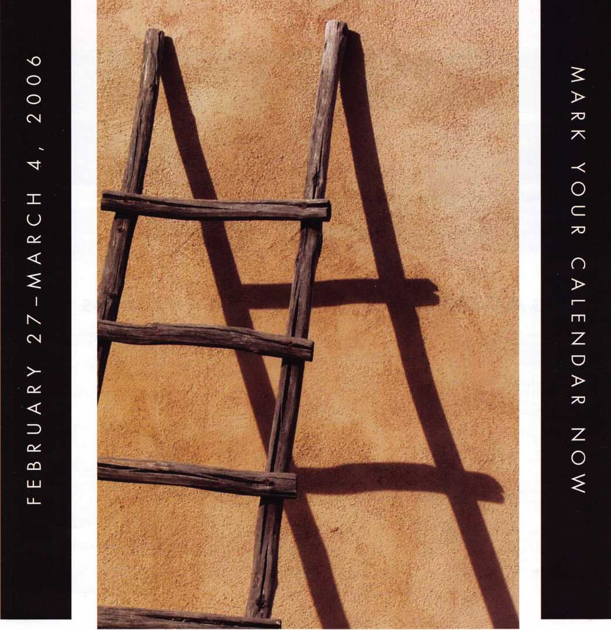

When it comes to learning about the  
latest in safes and vaults, time is of the  
essence. SAFETECH 2006 features an  
all-new menu of classes, covering every  
safe topic on the globe. Don't miss out!

SAVTA • 3500 Easy St. • Dallas,TX 75247  
(214) 819-9771 Fax (214) 819-9736  
Email: [convention@savta.org](mailto:convention@savta.org)



**u p c o m**

events

i n g

*O'*

*<*

*Z*

**Q.**

<

5

z

**z**

**o**

**o**

**CO**

|  |  |
| --- | --- |
| 1-4 SAFETECH 2006  Safe & Vault Technicians Assc. Annual Convention 2/27-3/4 Contact: [convention@savta.org](mailto:convention@savta.org) Albuquerque, NM | 30-1 CLA Tradeshow & Convention  Contact: [www.eurolockfed.com](http://www.eurolockfed.com)  Ontario, CA |
| 5-7 ISC West  Las Vegas, NV | 5-9 European Locksmith Federation 22 Virginia Locksmiths Association  [www.eurolockfed.com](http://www.eurolockfed.com) Transponder Class  Venice, Italy Chester, VA  Contact: Elliot Conner email: [va_locksmith@cox.net](mailto:va_locksmith@cox.net) |

North Jersey Master Locksmith Assc. 1 2th Annual Flea Market Sunday, 9am - 1 pm Contact: Jeff Sitar 973-777-0620 or Pete Sarailian 201-944-7547

6-7 Oklahoma Master Locksmith Ass 2-day session

Contact: Mike McGrew, CRL 918-333-9136

Tulsa, OK • Holiday Inn Select

11

7/8-16 Associated Locksmiths of America

ALOA 50th Annual Convention & Security Expo Las Vegas, NV

Contact: 800-532-2562 or visit [www.aloa.org](http://www.aloa.org)

9/15-16 Doyle Security Products

20th Annual Trade Show & Educational Weekend

Minneapolis, MN

Contact: Chantelle Gallagher

800-333-6953

UPCOMING ACE CLASSES UPCOMING PRP SITTINGS

3/16-19/2006 Secaucus, New Jersey • ACE Classes  
East Coast Region Security Show  
Contact: Bill Timmann, CML  
908-859-3135

4/22-23/2006 White River Junction, Vermont • ACE Classes  
Green Mountain Locksmiths Association  
Contact: Bradley Manchester  
802-8634153

4/22-23/2006 Fort Wayne, Indiana • ACE Classes  
Northern Indiana Chapter of ALOA  
Contact: Jeremy Rodocker, CML, CPS  
260-459-1500

|  |  |
| --- | --- |
| 3/04/2006 | Saturday 8:00 am • Albuquerque, NM • SAVTA '06 Satetech  Mayra Ocon 800-532-2562 x203 |
| 3/18/2006 | Saturday 11:00 am • Somerset, NJ • MLANJ  Bill Timmann, CML 908-839-3135 |
| 3/18/2006 | Saturday • Nashville, TN • Tennessee Org. of Locksmiths  Chris Cyree 931455-0202 |
| 4/01/2006 | Saturday 8:00 am • Ontario, CA • California Locksmiths Association Suzanne Harmony 714-632-6800 |
| 4/06/2006 | Thursday 9:00 am • Dallas, TX • ALOA  Mayra Ocon 800-532-2562 x203 |

5/13/2006 Detroit, Michigan • ACE Classes

Locksmiths Security Association Contact: Robert C. Nobel, CPL 810-385-9329

7/8-16/2006 Las Vegas, Nevada • ACE Classes

ALOA 50th Annual Convention & Security Expo Contact: ALOA Education [education@aloa.org](mailto:education@aloa.org) [www.aloa.org](http://www.aloa.org)

5/1 1 /2006 Thursday 9:00 am • Dallas, TX • ALOA

Mayra Ocon 800-532-2562 x203

6/08/2006 Thursday 9:00 am • Dallas, TX • ALOA

Mayra Ocon 800-532-2562 x203

7/13/2006 Thursday 6:00 pm • Las Vegas, NV • ALOA 2006

Mayra Ocon 800-532-2562 x203

8/26/2006 Saturday 3:00 pm • Dallas, TX • ALOA

Mayra Ocon 800-532-2562 x203

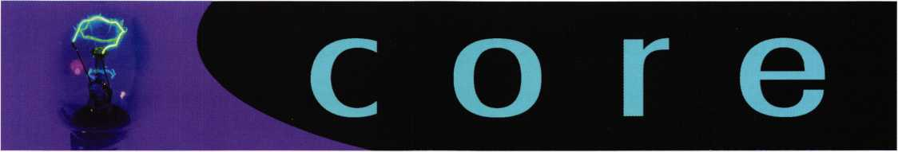

Noteworthy

ALOA Board Member Bill Smith poses with Dave Paulsrud at the Charter of the Indian Head Chapter.

In Memory

Richard M. Higgins from Show Low, Arizona recently passed away. He was 68 years old. Richard had been a member of ALOA since 1994.

Ingersoll Rand Security Technologies Announces Winners of 'Racing to Daytona1 Sales Contest

Top-Selling ADI Dealers Win Free Trip to Daytona 500

FORESTVILLE, CONN. - February 6, 2005 - Ingersoll Rand Security Technologies today announced the winners of its "Racing to Daytona" contest, in which the two top ADI dealers in terms of dollar sales and percentage growth are being sent on a free trip to the Daytona 500. Purchases of any and all Ingersoll Rand products from ADI branches in U.S. and Canada qualified toward the two categories.

ADI, a leading distributor of security and low voltage products with over one hundred locations in the US and Canada, is the main source for security dealers and integrators purchasing electronic security devices and systems for commercial and residential appli­cations.

The winners of this year's contest are Maureen and Stuart Lande of Maureen Data Systems in New York City and Gary Kielpinski and Richard Kemp of Advanced Audio Concepts of Vancouver, British Columbia, Canada.

"We are extremely pleased to announce the winners of our 'Racing to Daytona' promotion and are gratified that so many ADI dealers chose to participate," said Bob Stetson, Director of Sales of Ingersoll Rand Security Technologies. "Our partnership with ADI, North America's leading wholesale distributor of security and low voltage products, is a win-win situation for both companies."

Brands qualifying for the promotion included Schlage, Recognition Systems, Locknetics, Von Duprin, LCN, and Kryptonite. Products

included Schlage Wireless Access control solutions, Recognition Systems biometrics, Von Duprin electric strikes, Locknetics electro­magnetic locks and system components, LCN door closers, and Kryptonite cables, chains and padlocks.

The first place contest winners each received two tickets and two all-expenses-paid trips to see the Daytona 500 in February. Ten second place winners received Ingersoll Rand Impact wrenches.

The DAYTONA 500 is held each February at the Daytona International Speedway in Daytona, Florida. The event kicks off the NASCAR NEXTEL Cup Series season each year.

Ingersoll Rand Security Technologies

Ingersoll Rand's Security Technologies Sector is a leading global provider of products and services that make environments safe, secure and productive. The sector's market-leading products include electronic and biometric access-control systems; time-and- attendance and personnel scheduling systems; mechanical locks; portable security; door closers, exit devices, architectural hard­ware, and steel doors and frames; and other technologies and services for global security markets. In addition to Schlage, their security brands and businesses include Recognition Systems Inc., Von Duprin and Interflex. Ingersoll Rand Security Technologies' solutions range from biometric hand and fingerprint readers and employee time-and-attendance systems to electronic access con­trols, wireless locks and exit trims, electromagnetic locks, electro­mechanical strikes, electronic exit devices, power supplies, monitor­ing consoles and controllers, architectural hardware and mechani­cal locks.

From within the U.S., contact us at our toll free numbers 866-322- 1 237 (CT) or 888-737-6659 (CA) or visit us on the web: [www.schlage.com](http://www.schlage.com), or [www.recogsys.com](http://www.recogsys.com). Ingersoll Rand Security Technologies is a sector of Ingersoll-Rand Company Limited, a diversified industrial company serving transportation, manufactur­ing, construction, and agriculture industries. Ingersoll Rand brings to bear a 100-year-old heritage of technological innovation to help companies be more productive, efficient, and innovative. For more information on Ingersoll Rand, visit the company's web site at [www.irco.com](http://www.irco.com).

ADI

ADI is one of North America's largest wholesale distributors of security and low voltage products, with over 105 branch locations in the U.S., Canada and Puerto Rico. ADI's product lines include intrusion, fire alarm, access control, CCTV, telephony, residential and commercial A/V, wire and structured cabling and tools and hardware. For more information about ADI, visit [www.adilink.com](http://www.adilink.com).

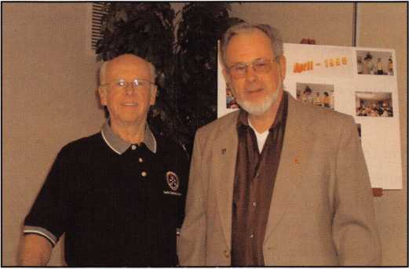

Keynotes • March 2006

Access Control

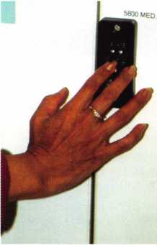

DRAWER

used, intuitive,  
user-friendly software

programs all-the locks, access trim, strikes and magnets-  
from a laptop or PDA. New users, access points and access  
privileges can be entered into the system in seconds.

Computer-managed (CM)  
standalone locking sys-  
tems, averaging around  
$1000 per door including  
installation costs, are the  
new workhorses of the lock  
industry, providing features  
typically found only with  
online, networked systems.  
Whatever the credential

With such CM locking systems, security professionals can become very creative. Systems, such as Schlage CM locks, Von Duprin CM993 exit trim and devices, and Schlage universal controllers, facilitate simplified, uniform access control administration. Multiple openings in an organiza­tion can be managed with a variety of stand-alone locking systems that share common software.

Without any network wires, users have the benefits of a networked system without the costs involved. Access and profile management is greatly improved without adding any extra software. Users and installing dealers can mix and match the best type of front-end solution for each opening without adding complexity to the system.

The system operator can easily control both users and access points based on time of day, day of week, credential needed and/or period of time. Reports show audit trails retrieved, access privileges granted and time functions established by either the user or door. With a laptop or PDA, the administrator goes to a door, plugs in the inter­face to the locking system right at the door, adds or delete users, determines which users can have access to specific doors at specific times throughout the day, and downloads audit trails of who has been through the door and when.

Bytes

Multiple access points. Multiple users.

One way to manage them.

Such a locking system offers new flexibilities in designing the right level of security for each door without sacrificing convenience. Multiple credentials can be easily employed within the facility. They can include codes, i-Buttons, mag­netic stripe cards and proximity cards. Facilities managers can also easily gain increased security by introducing biometrics into an existing installation. Since the user's hand or finger is the key, the biometrics reader positively identifies people themselves, not their keys, cards or codes.

Different credentials can be used on varying doors. Here's an example with a small medical lab. To avoid having to manage cards, biometric handreaders could be put on the back door, where everyone parks, to allow employees to enter. A biometric fingerprint reader with an electronic cabinet lock may also be the answer for where the pharma­ceuticals are kept. The two doctors may want keycode or proximity card access to their offices. The same software, working off a laptop or PDA, programs all. The office or facilities manager simply downloads information to the locking device and uploads audit trails in one step and moves on the next door.

Whatever the credential, administrators can perform vari­ous functions including momentary and maintained access, lockout, one-time use, supervisor and even linked access, in where a code must be used in tandem with a credential such as at a bank's ATM.

These CM locking system solutions can even manage up to 1000 users per opening (very useful for those facilities and campuses that have high turnover). They will also pro­vide audit trails for the last 1000 events. With multiple time zones, multiple time schedules, a variety of holidays and other time functionalities, administrators can grant multiple users different privileges regardless if they are using a hand geometry reader, proximity or magnetic stripe cards, codes, iButtons® or any combination within their facilities.

Keynotes • March 2006

High-Tech Locks

From Simple Electronic Locks to Computer-Managed Models, Hardwired Systems to Wireless Technology, Today’s Locking Systems are Evolving in Sophistication

George Nortonen

With the new flexibilities, increased security and lower costs offered by electronic locking systems, it is small won­der that they are revolutionizing the world of access con­trol. Moving from mechanical locks to an electronic lock­ing system is the first step many organizations take toward total, integrated access control.

Electronic locks allow organizations to retrofit doors to become part of an overall system, using the same creden­tials throughout a facility or even multiple facilities. Electronic systems even allow intermixing of credentials, using systems as simple as the electronic PIN-enabled lock or as sophisticated as online wireless configurations that connect doors or even elevators to existing access control systems. Electronic locking systems affordably add increased security to a larger number of doors while simul­taneously increasing user convenience.

While it might seem a daunting task to make the transi­tion to total integrated access control, there's a comfortable pathway that many organizations have followed. Those companies often start with battery-powered, programma­ble, standalone locks that add security and value while pro­viding a hassle-free upgrade path.

Programmable Electronic Locks

The first priority for any access control plan is to establish control over the origination and duplication of mechanical keys. Whether it's a storage closet, research lab, computer room, office or records room, the programmable locking system provides a simple to install, affordable solution for eliminating the distribution of keys. If the need is to pro­vide controlled access to multiple users sharing access to

multiple openings, programmable electronic locks and trims are the first step in a migration from mechanical key systems to fully electronic access control.

At an installed cost starting around $655 US per door, programmable electronic locks provide a solid choice for facilities with a limited number of users and access points. A step above the traditional generations-old strictly mechanical pushbutton lock, they are stand-alone, micro- processor-based, battery-powered locks that provide increased customer value. Until it receives an authorized code, the clutching lever simply gives way, discouraging vandals and others from breaking it to gain entry.

They also remove the worry of using up the capacity of the 17 or 19 codes that are currently available on older locks. These new generation locking systems are also at a price point of mechanical single code locks that require a cum­bersome process to change codes. With them, staff can quickly program up to 120 individual user codes, right at the keypad. Administrators can easily add or delete users in less than a ten second process. These programmable lock­ing systems operate on four off-the-shelf, AA alkaline bat­teries, which provide 80,000-plus cycles or approximately three years of use.

Recently introduced programmable locks additionally fea­ture iButton ports, 12-button keypads and standard builder's cylinders. Models are available for use with a wide range of doors, latches and exit devices, including narrow stile aluminum doors.

By providing iButton keyfobs in addition to access codes, managers achieve a higher level of security by preventing unauthorized entrance. Now, an access control administra­

Keynotes • March 2QOB

tor can choose to require a pin code, an iButton, or both a pin code and iButton to gain authorized entry. It's not just what you know that gets you in the door, but what you have as well.

Because codes can be easily and quickly added or deleted, security can be enhanced by increasing the frequency with which codes are changed, while also cutting down on the labor time and cost to accomplish this. This translates into a lower cost of ownership and reduced liabilities. The moment an employee who knows an access code leaves the company, security is at risk if steps to prevent future access are not taken.

As soon as an employee quits the company or a new employee joins the organization, administrators can imme­diately delete an old code/credential or add a new code/credential at the keypad to maintain increased securi­ty. This provides considerable cost savings associated with having to continually re-key a lock whenever an employee leaves or mechanical keys go missing.

Such a locking system is a perfect solution for institutional environments like hospitals, airports, corporate campuses, universities, or for commercial applications like managed properties, restaurants, retail establishments or other small businesses where key control and security is a concern.

For instance, in the United States, at South Carolina’s Rock Hill School District No. 3, these types of electronic locks are used to protect students, teachers and staff on several of its 33 campuses.

"COBRA and PRO Series locks are good devices for us to ensure secure schools," reports Mike Robbins, a locksmith for the Rock Hill School District for the past 18 years. Currently the school district has about 25 electronic locks installed at eight campuses. The locks are used to secure outside doors at elementary schools, to lock buildings when teachers and students go outside for recess, and to ensure that doors aren't left propped open. An electronic lock is also installed on a lab to protect expensive equip­ment.

"I’ve worked very hard to get electronic locks in the dis­trict, and so far everyone is really liking them," Robbins said. "The initial cost may be more, but you spend more money rekeying a facility if someone loses a key. Plus, you

can change the code and your facility is secure again in a matter of minutes. When you use mechanical keys, you have to go around and rekey all the doors. The electronic locks are easy to program and use and require almost no maintenance."

For retail outlets, narrow stile versions provide the oppor­tunity to add electronic access control to a wide range of existing aluminum doors. Millions of existing aluminum narrow stile doors can now benefit from a security and convenience upgrade.

Computer-Managed Locking Systems

The next step in an intelligent migration from mechanical locks to total integrated access control involves computer- managed (CM) locking systems. CM locks are ideal in sit­uations where older doors or facilities need to be retrofitted with higher-security locks. CM locking systems offer many of the same benefits as a networked, hardwired system, without the higher cost and additional care associated with routing network cable when retrofitting an existing facility with electronic access control. These standalone, program­mable, battery-powered locks are networked through soft­ware to provide audit-trail capability and time-based sched­uling for restricting access.

Whatever the credential used, a user-friendly software pro­grams all, including the locks, access trim, and offline hard-wired controllers, which manage strikes and magnets, from a laptop or PDA. New users, access points and access privileges can be entered into the system in seconds. They also provide an audit trail capability.

"Our future growth is the CM locks, so that way we can control when our teachers come and go in the district. Plus they will tell us who is coming and going," explains Rock Hill School District's Robbins. "The CM locks are a great standalone system for access control retrofits."

One CM lock is currently installed on a fitness room for teachers and students. Teachers are given the code, so stu­dents can only access it when a teacher is present. Eventually teachers will be able to use their ID badges to access the lock. The district plans to install more CM locks that will work with proximity cards.

**12**

Keynotes • March 2006

till

**LY ANY DOOR AND HAS ALL THE STYLE AND**

**NT. That’s why it’s all you need to carry.**

*Introducing the Schlage Accents™ Collection*

Schlage now provides you with the ability to retrofit virtually any door with the ultimate  
in elegance and security. The Schlage Accents collection is built on a revolutionary  
chassis designed to provide field-reversible levers on passage, privacy and now keyed  
functions. A patented adjustable through-bolt allows Schlage Accents handlesets to

retrofit over 70% of competitors

current designs. Special features like these, along

with concealed screws and decorative trim, allow you to reduce the inventory you  
carry while providing the perfect door hardware choice for homeowners who desire  
Schlage quality and security.

**To find out more about the finest line of decorative door hardware, visit schlageaccents.com.**

***Timeleim***

**An(fff)|ngersollfland business**

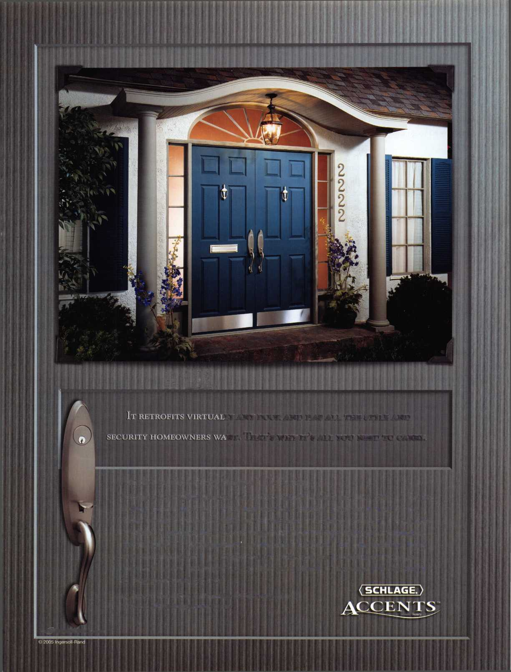

Similarly, Canadian Blood Services (CBS) is using CM locking systems to restrict access to high-security areas of its Vancouver facility, while also saving time and money versus the cost of using mechanical keys.

"Our building is a very tight security building," explains Dan Lee, facilities coordinator for British Columbia and the Yukon areas for CBS. "Only a certain number of staff are allowed to go through the doors secured with the CM locks."

At the Vancouver location, Lee manages 15 CM locks that control access to the lab area, the administration areas, the archives, and a supply warehouse. The center employs about 200 people and only a handful of staff members are allowed access to high security areas.

CBS uses HID proximity cards with the battery-operated, standalone CM locking systems. Using just one proximity card credential, staff members can be granted access to any combination, or none, of the high-security areas. Prior to installing the CM locks, CBS used mechanical keys at the Vancouver facility. Switching to CM locks has saved time on rekeying and simplified access control for CBS.

"The locks are really easy to program," Lee reports. He uses a laptop computer and LockLink software, but plans to purchase a handheld computer (PDA) for even easier lock programming. PDAs can be used to remotely tour the locks for programming and downloading of audits. Lee plans to add more CM locks at the Vancouver location in the coming months, as the facility undergoes a renovation.

Typical per door installation costs average less than $1,000 US, including installation costs. With such CM locking systems, security professionals can become very creative and provide a balanced approach to access control. Such systems facilitate simplified, uniform access control admin­istration. Multiple openings on a campus or in a building can be managed with a variety of stand-alone locking solu­tions that share a common access control software, simpli­fying management by eliminating redundancies associated with managing multiple systems. These battery-powered, standalone locksets and exit trim always provide code com­pliant free egress and are very easy to retrofit.

The CM system can support a variety of credential types including PIN codes, magnetic stripe cards, iButtons,

proximity cards and biometrics. Whatever the credential used, one intuitive, user-friendly software programs all-the locksets, exit device trim, strikes and magnets (through the offline controllers)-from a PC or PDA. Users and access points can quickly and easily be added and deleted from the system as well as assignment of access privileges.

Using the system's LockLink software, the system operator can easily control both users and access points based on time of day, day of week, credential needed and/or period of time. Reports show audit trails retrieved, access privi­leges granted and time functions established by either the user or door. With a laptop or PDA, the administrator goes to the opening, plugs in the interface to the locking system right at the door, and uploads new access instruc­tions to the lock while downloading audits of who has been through the door and when.

Access rights can even be assigned to users by credential and/or time function, providing the system operator with maximum flexibility to control the flow of people into, through and out of a facility. Selectable functions include time zones, time activation and expiration, auto unlock time scheduling, first person in and holiday scheduling. A variety of reports are available to help manage a facility more efficiently including audit trail data, access privileges data, and time function schedules by user or door.

Whatever the credential, administrators can perform vari­ous functions including momentary and maintained access, lockout, one-time use, supervised and even linked access, in which a code must be used in tandem with a credential such as at a bank's ATM. Linked access reduces the proba­bility of lost or stolen credentials from providing unautho­rized access. These CM locking devices can even manage up to 1,000 users per opening (very useful for those facili­ties that have high turnover). They will also provide audits on the last 1,000 events that occur at the opening.

Next Step: Inviting Third Parties

Beyond CM locking systems are the hardwired locks, which let users use a CM-type lock monitor door openings with their own existing, third-party access control panels and software. That means locksmiths don't have to go to the locks themselves to program them, or download audit trail information. This open architecture platform seam-

**14**

Keynotes • March 2006

ALOA

2 Million

at Your Fingertips

Internet Shoppers are Looking for a locksmith night

ALOA Partners with ServiceMagic^ to give members discounted access to leading online marketing solution. Through the relationship, our members will now have access to ServiceMagic's online marketing solution that can dramatically increase revenue and profits.

As an ALOA member, you can now receive targeted cus­tomer leads from consumers looking for a locksmith in your area through ServiceMagic. The program gives you immediate access to ready-to-buy consumers.

* Increase Your Customer Reach - ServiceMagic gets you access to more than 2 million unique visitors and more than 150,000 consumer leads each month.
* Target Your Leads - Get matched consumers looking for locksmiths in only the locations you want to work.
* Increase Your Profits - Service Professionals who have used ServiceMagic for at least a year report grow­ing their business by 28% on average. Many report that ServiceMagic has become their lowest-cost form of advertising.

Free Enrollment Fee for a Limited Time - On behalf of the Associated Locksmiths of America, save $99 by enrolling now.

Unlike other marketing initiatives, with ServiceMagic there are no long-term contracts or ongoing monthly or annual fees. Once in, you pay only for the targeted customer leads you receive. To learn more, please visit: [www.servicemagic.com/ext/771036](http://www.servicemagic.com/ext/771036)

**To learn more, visit**

**<http://www.servicemagic.com/ext/771036>  
or call 888.528.9179**

SERVICE^

**MAGI** Cu.

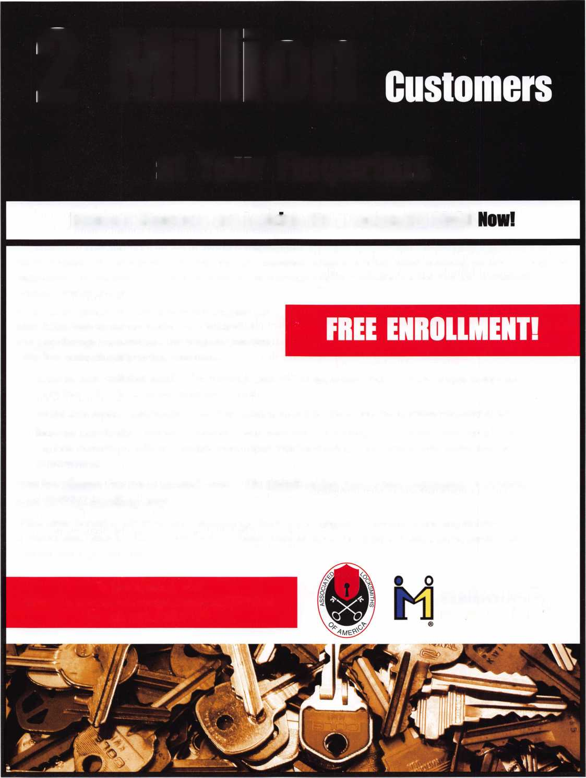

lessly connects the specially designed door lock to a panel interface board (PIB) that connects to any present access control panel. There is no need for separate components or multiple manufacturers' products. Users access the VIP lock with either magnetic stripe or HID proximity cards.

As a result, credential data and door status information required by the access control panel, such as door position or request-to-exit status, are passed via RS-485 communi­cation from the lock to the panel via the PIB provided with the locks. The access control panel maintains control of the lock status and status indication on the VIP locks as it does with present electric strike or electromagnetic lock­ing systems. All monitoring is captured at the remote mon­itoring station.

Regardless of software employed, users have the benefits of a networked system without the costs. Access and profile management is greatly improved without adding any extra software. Users and installing dealers can mix and match the best type of front-end solution for each opening with­out adding complexity to the system.

The system operator can easily control both users and access points based on time of day, day of week, credential needed and/or period of time. Reports show audit trails retrieved, access privileges granted and time functions established by either the user or door.

Going Wireless

The last destination on today's pathway to total integrated access control is the application of wireless technology in physical security environments. These innovative locking products benefit from faster, less costly installations.

The business case for deploying the new wireless systems in networked openings is compelling. Actual installations demonstrate a wireless solution can have a substantially lower installed cost than an online access control system. Wireless systems use less hardware and install five to ten times faster. With wireless systems, it becomes extremely easy to retrofit electronic access control solutions in facili­ties and applications that have previously held back due to budget constraints or installation limitations.

In addition to providing access control at a door in the form of a wireless lock, organizations can now take advan­tage of wireless solutions for elevators, gates, exit devices and electric strikes. Importantly, the wireless system easily integrates into all existing access control systems and cus­tomers can continue to use their existing keys or ID cre­dentials.

Pathway as Long or Short as Required

When planning the move from the mechanical world to electronic, networked or wireless locking systems, remem­ber that the transition does not have to take place overnight and it does not need to be total.

Adding electronic locking systems to access points as time and budgets allow is a sensible migration plan for any organization, no matter how large or small. A large facility may have dozens of doors with varying levels of security needs. A broom closet may be adequately secured with a simple offline lock, while surveillance or computer rooms may demand high-security locks that are integrated with access control systems. The right lock system for a given door may be found anywhere along the electronic migra­tion path.

**16**

Keynotes • March 2006

Los Angeles-Area District Secures Schools with Schlage Computer-Managed Locks

La Canada Currently Uses 50-plus CM Locks; District Plans Call for Complete Switchout

Ingersoll Rand Security Technologies' Schlage Electronic Security recently announced that the La Canada Unified School District, located just north of Los Angeles, is upgrading from mechanical locks to Schlage Computer-Managed (CM) locks at all five of its campuses. Currently, 50-plus locks are being used in the district to secure areas including gymnasiums and com­puter and science labs. The dis­trict plans to install a total of 98 locks at its existing schools and at a new district office that is now being built.

Schlage CM standalone locking products provide features found traditionally with online, net­worked systems. User-friendly software on a laptop or PDA pro­grams the locks, access trim, and offline hard-wired controllers, which manage strikes and mag­nets. New users, access points and access privileges can be pro­grammed into a CM lock in sec­onds. Users can select proximity, magnetic stripe, PIN or i-Button credentials individually or in combination. The CM lock also provides an audit trail for down­load onto a laptop or PDA.

—

Keynotes • March 2006

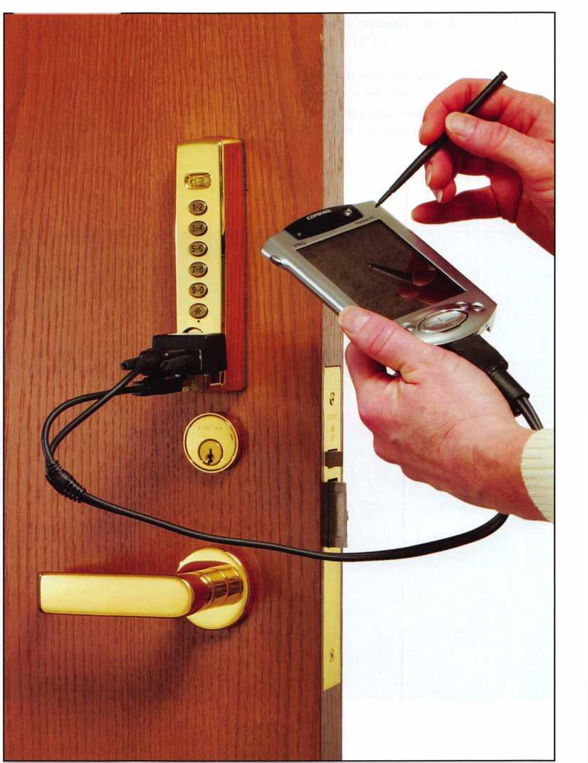

"We were using standard mechanical keyed locks, but they were too labor intensive and costly to rekey," reports Bruce Tiffany, a district locksmith. "The major benefit of the CM locks is that it's easy to delete a card out of the system with­out rekeying an entire school. The electronic locks also pro­vide a history of who has entered and at what time, which is a real plus."

District employees use proximity cards to access the CM locks. If a card is lost, Tiffany simply issues a new one. The locks are easily reprogrammed using a handheld PDA.

Previously, if a principal lost a master site key, the entire school would have to be rekeyed. About eight years ago, Tiffany had to do so at a cost of $35,000, including all interi­or and exterior doors. However, there is no extra cost out of the budget to reprogram the CM locks.

La Canada faculty like that they now only carry one card instead of being responsible for several keys on a ring.

Athletic Department instructors who used to carry about 30 keys now have just one card and three to four interior keys.

The CM locks also allow for flexible access control when out­side groups use district facilities. CM locks can control access to restrooms at the elementary schools on the week­ends, when Little League and other youth sports organiza­tions need them. The district can monitor the facilities and see if anyone is abusing the privilege.

The CM locks are also extensively used at the school gymna­siums for outside user groups. District locksmiths can pro­gram in specific times and specific days that outside groups are allowed in. If there are any abuse issues, the district is able to deal with them immediately.

"We looked at several other companies, but Ingersoll Rand had the best locks for the price, and good customer service," Tiffany notes. "We have also found the system to be very user friendly."

He expects that within one and a half years, all the schools in the award-winning district will be secured with CM locks.

Want to Advertise in our Next Issue ol Keynotes?

**For advertising information,  
Contact Kim Hammond**817**-**645-6778

8

Keynotes • March 2006

fverv

bodV it

**FKI**

SECURITY GROUP

*<&>*

Security & Safety

Preven Source. Proven Solutions.

*Com®*C.

SECURITY PRODUCTS

**.. You** MIGHT TAKE

IT HOME!

One Lucky Member Attendee at ALOA  
2006 is going home with this gorgeous  
mint-condition 1956 Ford Thunderbird.

A ticket will be given to each ALOA  
Member who registers and attends the  
show. Someone has to win it, and it  
might as well be YOU!

(Must be present to win. Exhibitors,  
Employees. Family Members of Employees, and  
nonmembers are not eligible for this door prize.)

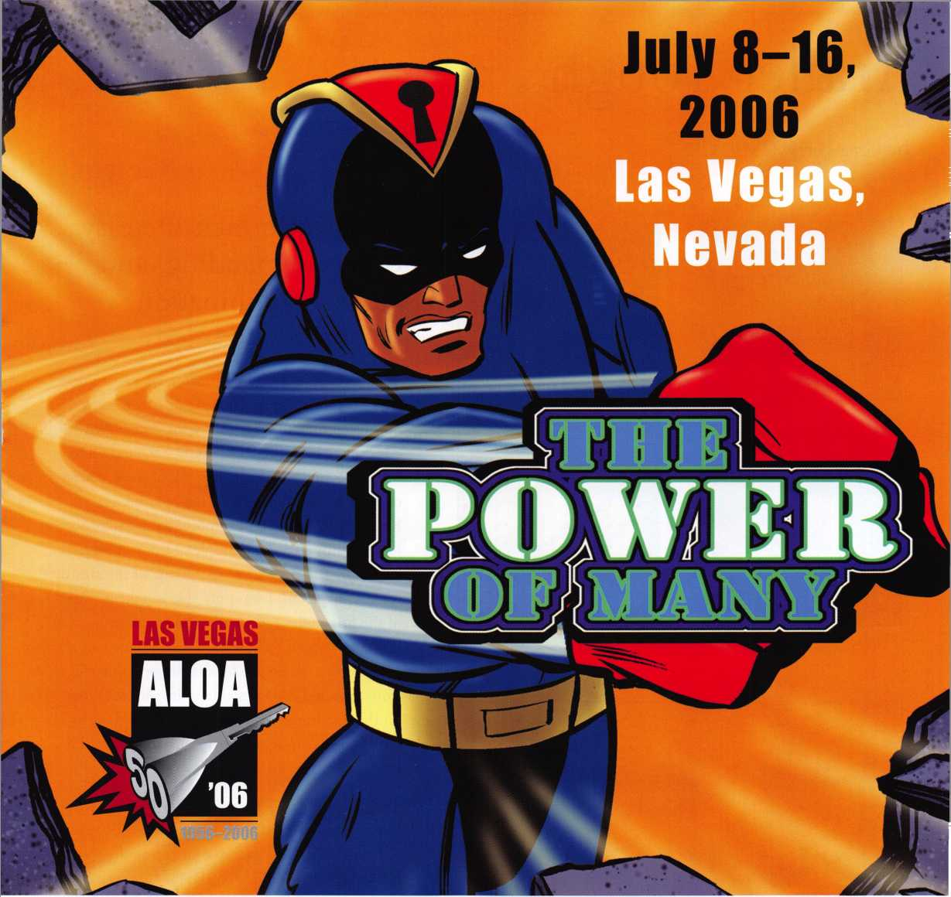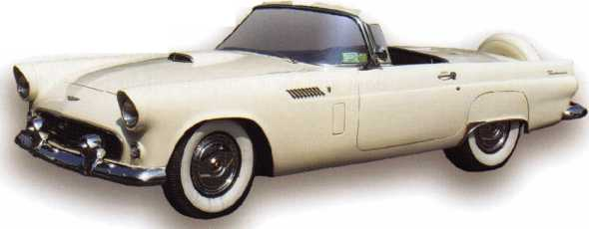

Trailer Tough

by Greg Perry, CML, CPS

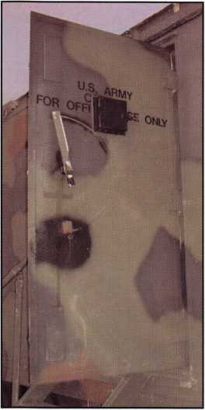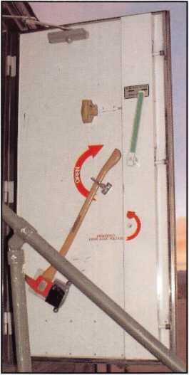

Photo 1

Photo 2

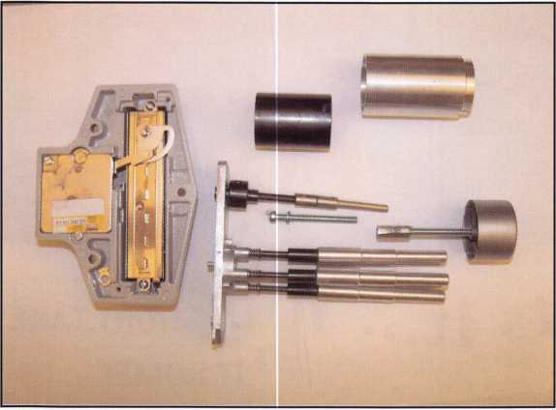

Photo 3

Some customers are easy, others demanding, and some a combination of both.

We have a government contractor for a customer who fits this category. They are easy to work with but demanding in what they want. They have asked us to install Kaba Mas CD-X07 and CD- X09 locks on shielded trailers. All of these trailers came from the trailer manufacturer with a Kaba/Ilco/Unican 904 rim mounted push button lock pre-installed. An example of this can be seen in photos 1 to 3. (Due to the nature of the area the trailers are placed, I was only able to take pictures of the first trailer I worked on several months prior to the last install.) The manufacturer added an extension to the bolt to lock the door boltwork from opening. I’ve been able to install a CD lock on the doorframe with the strike on the door to satisfy their requirements without too much diffi­culty.

The last trailer they received is a different design. First, it is a 4 1/4” thick door. Second, the frame is different precluding me from installing the KabaMas CD-X09 lock on the frame. I was able to recess the CD lock into the door slightly and that lock was installed. The third problem posed the most difficulty at first glance. They wanted a push button lock similar to what the trailer manufactur­er installed on the other trailers. I didn’t like the design they used. It was difficult to assemble on the door and the nameplate might be a little interesting

Keynotes • March 2006

Simple to use, install, and maintain. Basic digital entry as  
simple as a single stand alone digital keypad for economical  
applications - or programmable digital keypads with access  
for hundreds of users and multiple doors and/or gates.

Complete systems that can include electric locks and  
access control devices linked to weigand control boards -  
all manufactured by DKS.

* Durability - backed by more than  
  50 years of Made-in-the-USA  
  manufacturing and expertise
* Outdoor use in all weather
* Easy to install magnetic  
  locks for both doors and  
  gates - a full line available  
  from 300 - 1200 lbs  
  holding force
* Vandal resistant - DKS

keypads feature:  
stainless steel  
faceplates, galvanized  
steel sub-plates, and  
rugged steel cabinets

fmh Button

To Cal

We use DoorKing because they have a full line of products which provides us with one-stop shopping and they have a great customer service department

*Scott Brose, Bejan Souferian* Co-Owners, Scotland Entry Systems, Inc.

Van Nuys, California

ACCESS CONTROL SOLUTIONS

for over fifty years

**surface mount**

*nom*

since 1948

**Parking Control Gate Operator Telephone Entry**

**1504 with intercom**

**magnetic lock**

Locking and Entry

**single and multi-door access control**

**flush mount**

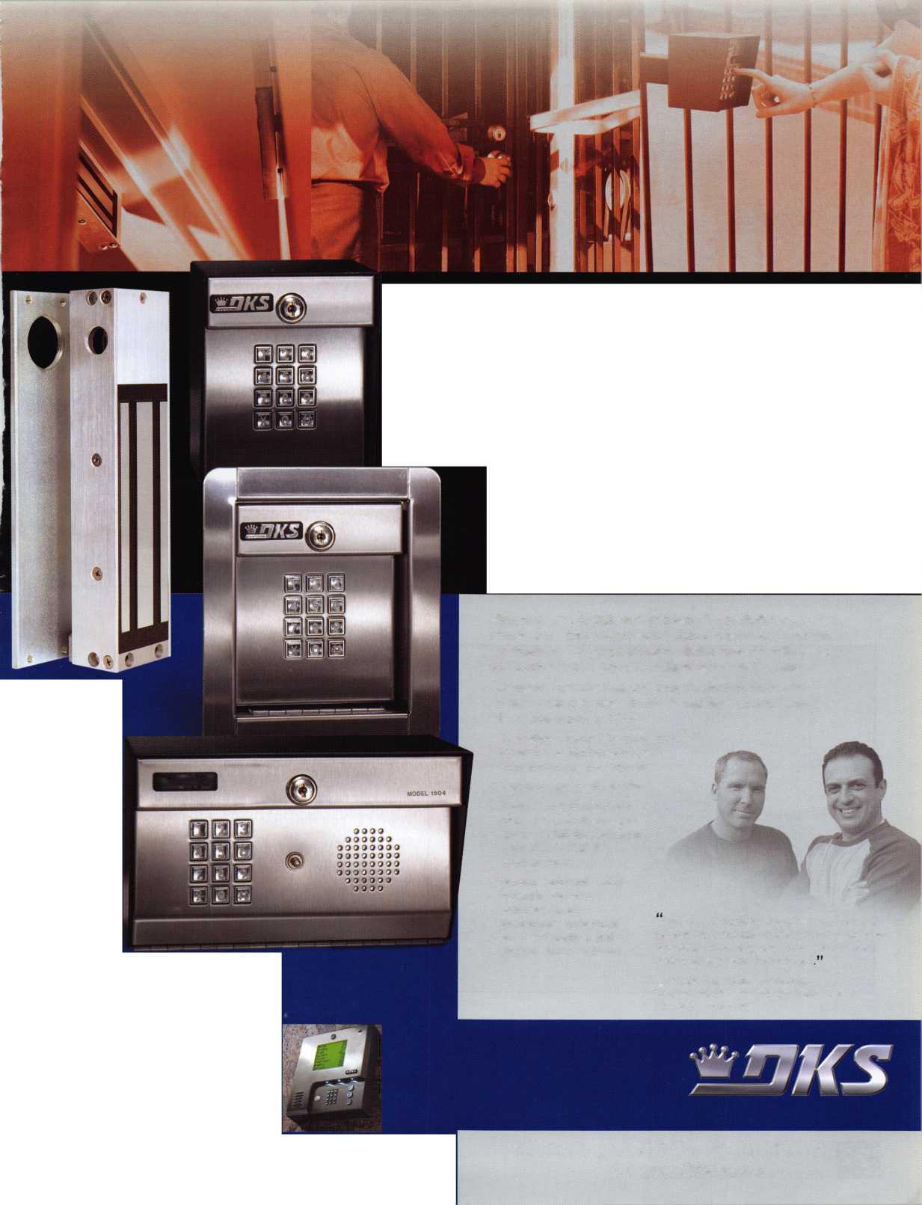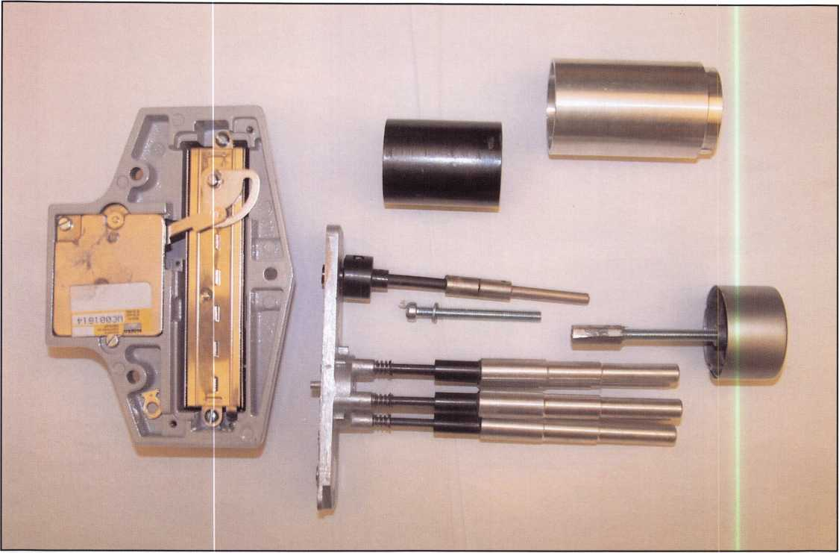

Photo 4

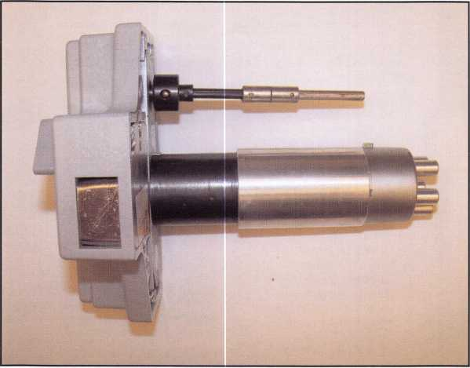

Photo 5

to create. Instead, we disassembled the tube assemble that came with the lock. One of my coworkers has a machine shop in his garage. On a lathe he made some button extensions. An exten­sion was also made for the outer tube. We cut the head off of a 3” long screw and used a coupling nut to extend the screw to hold the cap in place. The coupling nut needed to be turned round to clear the inside diameter of the button extensions. The only piece left to extend was the thumb turn. I looked through my old parts bin and found an old style spindle for the thumb turn. It was glued to the existing spindle. The disassembled lock can be seen in photo 4, completed in photo 5.

Keynotes • March 2006

I considered a few possibilities and settled on..

One last part to modify. The lock needed to be mounted away from the edge of the door in case they wanted to restore the shielding and also to clear the handle and bolt work that locks the door. This time the lock bolt needed to extend like a rim lock normally would behind the doorframe. I considered a few possibilities and settled on using a National Mfg. V832 heavy-duty barrel bolt. This would provide both a larger bolt to secure the door and a pre-made strike. I started by drilling the end of the 904 lock bolt with a #7 drill bit for a 1/4” 20 thread. This is the same size rod that comes with metal door flush bolts. Next, I disassembled the barrel bolt and chucked the bolt in a lathe. The center of this bolt was drilled for the 1/4” 20 thread. The finished lock assembly can be seen in photo 6 (on next page).



**SAFE CORPORATION**

ELECTRONIC SAFES  
FROM A & B

Battery powered

Digital key pad and  
credit card actuated

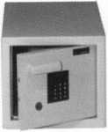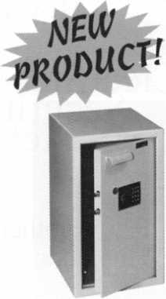

RS-10

RS-5

800-253-1267

114 S. Delsea Drive, Suite 3 856-863-1186

Glassboro, NJ 08066 Fax 856-863-1208

Keynotes • March 2006

Tl*t rrrr'

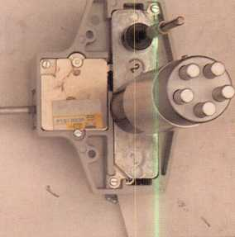

Photo 5

Unfortunately the trailers are now in restricted area. This means as men­tioned earlier that I could not take pic­tures of the finished product after it was installed. Several times in the past customers have wanted a variation of this and we’ve turned them down for lack of a product. I believe this exten­sion idea could be produced by most machine shops for under $100.00. Although, not inexpensive, it fills a need for a reasonable cost.

Although, not inexpensive, it fills a need for a reasonable cost.

You need it When?

**How about now!? :-)**

☆

ClearStar  
Security

Network

Another Special  
Value-added Benefit to your

ALOA Membership! Click here

**i**L

[www.clearstar.com/ALOA](http://www.clearstar.com/ALOA)

Keynotes • March 2006

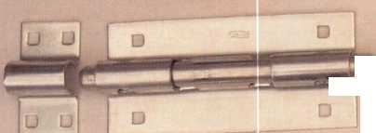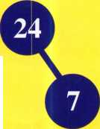

Kaba Ilco Corp participates in a Modern Marvels Program

=Hcn

In August 2005, Kaba Ilco Corp, Rocky Mount North Carolina hosted a film crew taping segments for the Modern Marvels television series. The Modern Marvel series presents stories behind the innovations and technologies that have altered our way of life.

The program in which portions of Kaba Ilco manufacturing processes and products will be covered is entitled Modern Marvels: More Hardware. From hammers to sandpaper, from keys to pushbutton locks, the program will provide an entertaining and educational overview of the hardware store and its evolution.

As more products are imported and independent business owners give rise to the larger retail stores, an American tradi­tion is still being preserved in North Carolina. Kaba Ilco Corp located in Rocky Mount North Carolina, is the world s largest key blank, key machine and replacement lock cylin­der manufacturer. To the west, Kaba Access Controls, Winston-Salem, North Carolina is a leading innovator and manufacturer of mechanical and electrical commercial push­button combination locks that secure airports, government buildings, businesses and more.

Many people depend on American manufacturers and dis­tributors for jobs and livelihoods. Then there are those of us who still prefer to shop at an independently owned and operated business. To be greeted by name when you walk through the door and have someone always ready to help you make a purchase. It s an American tradition!

Chuck Murray, General Manager, Kaba Ilco Corp was the spokesperson for the factory production film segment. The segment shot in the Rocky Mount manufacturing facility featured the manufacture of keys beginning with the produc­tion of brass through to the packing process. Tom Nazziola, Kaba Access Controls provided a segment on Pushbutton locks

Modern Marvels: More Hardware is scheduled to air on the History Channel, December 6, 2005. Check your local list­ings for the time and any possible schedule changes.

For additional news information on this event contact: Chuck Murray, General Manager at 800-334-1381 or e- mail: [cmurray@irm.kaba.com](mailto:cmurray@irm.kaba.com)

Download photos of the film shoot in the Kaba Ilco Factory at <http://www.kaba-ilco.com/ilco>

**25**

Keynotes • March 2006

Security at Your Fingertips

by Brian Costley, CML, CMST

What does technology do for us?

Well, for one thing, it allows us individually and collective­ly to do more than was possible in the past. For instance, when I was a young boy, I could complain that there was nothing worth watching on television.. .not one worth­while thing on any of the three channels the family televi­sion could receive. Now I can complain that there’s nothing on 180 channels. That’s progress. And instead of dealing with one channel selector knob on the front of the TV, I now routinely hunt around the living room for one or more of the many remote controls that will eventually help me discover that there is indeed nothing on TV.

Technology has made my life a lot more complex in this respect, in spite of my unwavering belief that one of the principal roles of technology should be to make life simpler.

Still, as much as I mumble under my breath about the complexity of simply watching television in the 21st centu­ry, I don’t want to go back to the 1950s and that 12-inch black and white box connected to an ugly, unstable anten­na up on the roof. The set took at least half a minute to warm up, the picture quality was marginal at best, and it seemed that Dad was always taking the back off to remove tubes for testing at the local drug store. Modern home entertainment equipment is a bit more reliable, but it hasn’t simplified anything. What it has done quite nicely, howev­er, is massively broaden the scope of what is available to occupy our leisure hours. We’ve got huge, high definition screens, tiny video iPods“, cable, satellite, VCRs, DVDs, gaming machines, home video, and more innovations being announced every week.

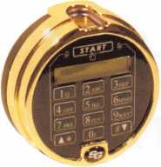

Compared to many other industries, electronic technology was relatively late in coming to the security industry, espe­cially in the area of safe locks. Even semi-reliable locking devices didn’t appear in any significant numbers until the late 80s. However, since that time they have grown in number and complexity. Twenty years ago, a sophisticated safe lock might have a dual-movement timer attached that would delay the final unlocking until a predetermined time period elapsed. In fact, S&G still makes one (the Timebination“), and it enjoys significant sales. There is also still a mechanical lock that incorporates a duress and lever position switch. That’s about it for special features, and the operator is still stuck with the “dial so many times in this direction, then so many times in that direction” inconven­ience.

Is it any wonder that electronic locks, with their “just push the buttons” approach have gained such widespread favor? And then there are the many features that the new technol­ogy has brought. Even the simplest models usually incorpo­rate multiple codes and time delays. The more sophisticat­ed end of the spectrum features full function time lock capabilities, multiple door control, audit trails, multiple modes of operation (single, multi-user, supervisor/employ- ee, and dual control), programming over the internet or an intranet, remote monitoring of functions, and even the capability to report exceptions to “normal” use of virtually any lock operation. It’s fast approaching the point where, if you can think of it, you can get a safe lock to do it. The price to be paid is...well, the price to be paid. More fea­tures come at an increased price. And the more sophisticat­ed the lock, the steeper the learning curve to get it to do all the marvelous things it is capable of doing.

Still, many of us long for the other thing that technology is supposed to do is simplify its own usage. Shouldn’t technol­ogy become easier to use as it grows in sophistication? The



Keynotes • March 2006

Features & Benefits

* Industrial Strength Combination Lock!
* Resists Hammer and Re-bar Attacks!
* Hardened Steel Full Metal Jacket!
* Hardened Steel Full Metal Jacket Shroud!
* Weather Resistant Black Electrocoating!
* 7/16” Chrome Plated Molybdenum Shackle!
* Inside Shackle Clearances: 1 ” and 2”!
* Shackle Pull Strength: 2,750 pounds!
* All Brass Inner Mechanism!
* Four All Brass Dials!
* 10,000 Changeable Combinations!
* Quick Delivery: Shipped from Stock!

*Combination*

Security Products

**A Division of The Eastern Company**

*tML-Security Priauets*

**301 West Hintz Road Wheeling, IL 60090 Telephone: 800.733.8588 Fax: 847.537.1881 vsnvw.cclsecurity.com**

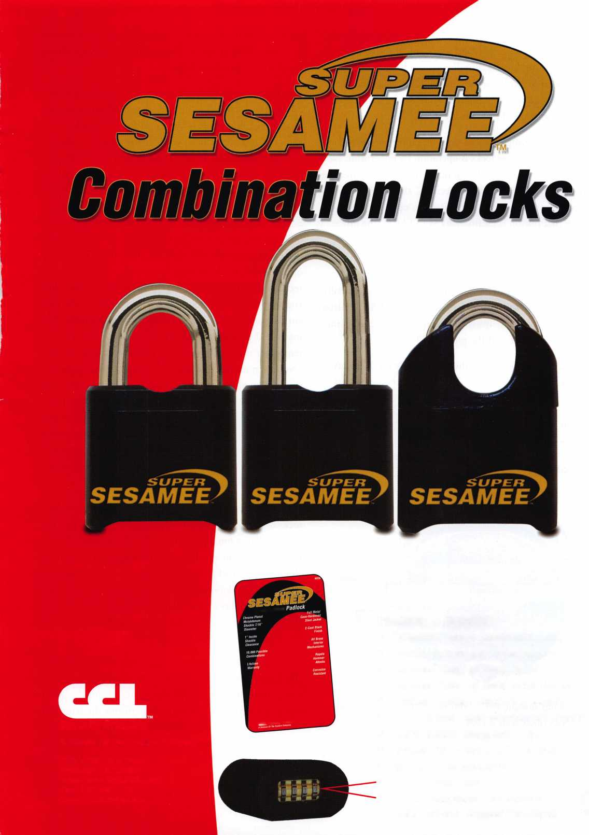

Biometric Keypad, introduced just last year by Sargent & Greenleaf, does just that, and thats one of the things that makes this product so appealing. It can be used with any existing 6120, 6123, or Z02 model lock (old, new, or any­thing in between), making it a prime retrofit product for a large population of locks that is already in use.

The most exciting function that the Biometric Keypad adds to one of these locks is operation by fingerprint. Not only is there no more “dial so many times in this direction, then so many times in that direction,” there isn’t even the need to push more than one button to open the lock.

Since that button is clearly marked “START,” the process is pretty fool-proof. It goes like this:

1. Press the START button.
2. Wait about just over a second for the system to initialize and turn on a little green LED next to the START button. The LCD will read “Initializing Sensor” between the time you press START and the green LED lights.
3. Place your fingertip on the reader while the LCD says, “Place Linger or Enter PIN,” and hold it there until the green LED goes out (about 3 seconds).
4. The Biometric Keypad signals the lock, and the lock opens.

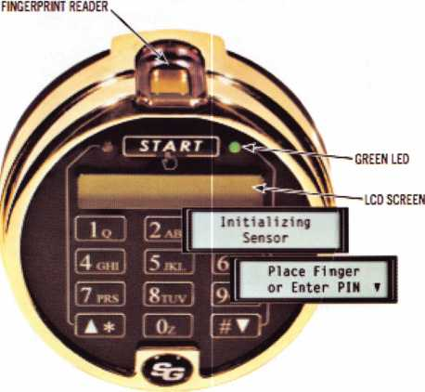

You could actually reduce this to “Push the START but­ton, and place your fi nger on the reader.” Yes, it’s that sim­ple. Safe owners will feel like they have reached the ulti­

mate in security—the safe stays locked until it recognizes its master. Then it opens. This is what technology should be all about, simplicity of use.

The Biometric Keypad will operate your safe lock three different ways, by selecting one of two different opening modes. The first mode is fingerprint or PIN mode. It allows you to open the lock using either a valid code or enrolled fingerprint. If you choose not to enroll a finger­print, the lock can only be opened by entering a code, just like a standard keypad (how dull). If you enroll a finger­print, you have the option of opening your lock with either a code or fingerprint. The second opening mode only lets you operate the lock when a code and the finger­print that goes with that code are presented. The last option, while the most time consuming, raises the level of security significantly. The fingerprint or PIN mode allows you to give access to your safe to others without the inher­ent dangers of writing down codes or combinations. For instance, I periodically ask my two grown sons if they remember the code to my safe. The answer is invariably “No,” even though I’ve given it to them at least a dozen times. If anything happens to me, how are they going to get to the documents stored in my safe? That lapse in memory could end up costing time and money to over­come. With a Biometric Keypad, I can store a fingerprint for each of them in the system. Now they don’t need to remember a code. As long as they bring the appropriate finger with them, they can access the safe.

How many fingerprints can you store? Depends on the lock. A 6120 is capable of holding up to nine codes. You can enroll one fingerprint for each code position. The math says we can enroll up to nine fingerprints when the Biometric Keypad is connected to a model 6120 lock. The 6123 and Z02 locks are both capable of holding seven dif­ferent codes, plus a time delay override code. In this case, the keypad can hold seven different fingerprints; eight if the time delay override is being used.

The ability to recognize authorized fingerprints is the only additional function the Biometric Keypad adds to a lock. Other than that very significant enhancement, the lock to which the keypad is attached still performs the same func­tions it performed when attached to a standard keypad. When it comes to programming, however, the Biometric

Keynotes • March 2006

Figure 1

Changing the Master Code

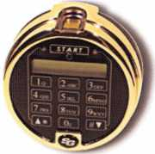

*t*T*it f| ^ butte# «t tire bottom of tse teypfcJ wtren tbrt screen appears.

Press the SIARl button tatsri jast above the LCD screen. Ibis screen wi8 appear for about a sweat then iuterrsatrealV cbisge to the neat screen.

Enter ne sock’s S-bigst master cede, toiscwfd b» a when prcmpted bi this scree* I?* factory default master code «s 1-2-34-5-6.

Press 2 to seieet tse loci Setup cotton. Youcaa press tse up or peers anew te* to get to CM semi before you press 2,«you may press 2 immediate!).

Ester year new 6-tgP master cose, teSowed by *.

lire screen appears wfcfe you are entering year sew master code.

lo centum, enter your new $-digd master code agars, followed by *

Ik* screen centos that lire new master code has Bees set. tire o« master code no longer works.

Don't press any mere buttons u&t! the display goes bank

Keypad performs much more intuitively and elegantly. The key is the two-line LCD screen located just above the num­ber buttons. The keypad generates messages and options to guide you step-by-step through the programming process, whether you are setting the mode of operation or simply enrolling an authorized fingerprint into the system. I’ve conducted a couple of Biometric Keypad training classes for independent technicians. First, we program all or most of the features of a 6123 lock using a standard keypad. Then we attach a Biometric Keypad and perform much of the same programming. The comment most often heard is, “Wow! This is so much easier. Why didn’t we start with this keypad?” The answer is obvious. Since the lock can be used with either a standard keypad or the Biometric, it’s necessary to know how to program it in either configuration. It just happens to be a lot easier when the lock is connected to a Biometric Keypad.

gerprint by measuring the capacitance between the ridges of your fingerprints at many different locations. That means that the reader cannot be fooled by any type of image, such as a fingerprint lifted from a drinking glass. It also means that the finger must be alive. The electrical properties of an appendage change when it’s removed from...well, you get the picture. In short, this is not the down and dirty fingerprint recognition technology that you may have seen in the past.

It’s first-rate, top of the line.

Figure 2 illustrates the steps necessary to enroll a fingerprint into the system. You will note that the keypad requires you to present a fingertip to the reader three times in succession.

Figure 2

Enrolling a Fingerprint

I uuuV.1,"^'''! Press the START b*tcn tatted just above tire ICO screen. fibs screen wtB ab°ut *!h4fl change totbe rreut screen.

Enter tire ta's 6-dtgis master code, followed bS # when promoted By this screen.

Your fingerprint ms been enrolled, tad you cm now use t? Jo open {Be kxk m iren of a code.

Press the rT button at the bottom of the keypad when tlks screen appears.

Enter the sock's 6-digd master code, followed by # when prompted by this screen,

fse factory default master cose is 1-2-34-5-6.  
ess 3 to seed the f mgerornt Setup option. fco tan press the up or down wow  
1 to get to tbs screen before you press 3. or you may tress 3 tmmedafefy.

Press 2 to select Enroll. Toucan press lire up or down arrow hey to get to the appropriate screen tt

you press t or you may press me number far your select**! inmodiuteV

Press 2 for Enroll

Enter 1. followed by#.

lo centum, eater tire lock’s 6-da*

'ester code again. toiSowed by ».

You wit be instructed to place your Mtger os the keypad

sensor 3 times to create a detailed image, these scmsiw  
repeat until tire fingerprint sas been scanned 3 times.

Don't press any more buttons until the display foes blank

The software then composites the data to create the best pos­sible data set that accurately describes the fingerprint in elec­trical terms. In simple terms, the keypad takes three sets of measurements of your finger’s electrical properties so that it can recognize it faster and more accurately in the future.

Lock programming is accomplished through a layered menu system which takes you to the function you want to access by presenting numbered choices that zero in on exactly what you want to accomplish. You scroll through the menu choic­es using up and down arrow keys (which also double as the * and # keys), and make selections with number keys. It’s very simple. Figure 1 gives an example of how to change the lock’s master code.

The Biometric Keypad uses advance fingerprint recognition technology. It’s referred to as a silicon-based active capacitive reader. It creates a mathematical representation of your fin­

Removing a fingerprint from the internal database is even easier, and you’ll find that all code and programming func­tions become much more intuitive. The Biometric Keypad will even tell you when you are trying to perform a function that is out of sequence, or if you are attempting to create a new code in a PIN position that is already in use. It’s about as foolproof as a keypad can be.

Installation of the Biometric Keypad involves about the same level of difficulty as installing a standard S&G keypad. Like anything else, the first one will require you to read the instructions and pay close attention to what you are doing.



Keynotes • March 2006

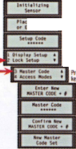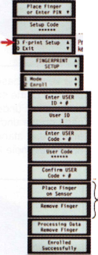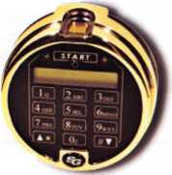

After that, you’ll sail right through the install in a matter of about four or five minutes. Most of the installation steps are pictured here, and I would strongly recommend that you read the complete set of instructions and/or view the installation video available on the Sargent & Greenleaf website ([www.sargentandgreenleaf.com](http://www.sargentandgreenleaf.com)). It takes you step-by-step through the installation process, and even covers the initial programming setup and enrollment of a fingerprint.

The Biometric Keypad raises our expectations. It doesn’t just introduce new technology to safe lock security, but it also brings true ease of use, both for the user and for the installer who is expected to accomplish the initial setup. I don’t know about you, but this is what I’ve expected from technology all along.

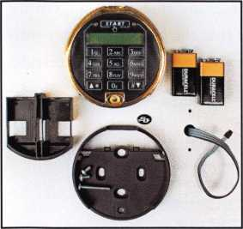

Here are the components of a Biometric Keypad kit. Note that it comes complete with batteries.The cable for an existing lock is shown coming through the spindle hole of a safe door.

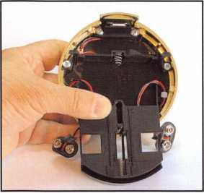

The batter box is placed in the back of the keypad as shown, and the battery connec­tors are routed through openings in either side of the box. This helps keep them in the proper position for attaching the key­pad to the base. You will need to hold the battery box in this position as you place the keypad over the base.

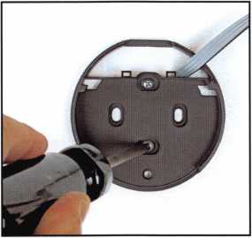

The keypad base is placed over the spin­dle hole of the safe, making sure the lock cable is not under the raised mounting pads on the underside of the base. It’s attached at standard mounting base/dial ring screw hole locations.

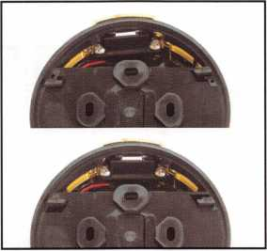

The back of the keypad incorporates two “feet” (indicated by white arrows) that will mate with openings in the base. In this photo, the back of the base is shown with the keypad mounted to it. The keypad is placed over the base rotated just a few degrees clockwise to allow the feet to engage the base. Once they’re engaged, the keypad is rotated back counter-clock­wise to lock the feet in place.

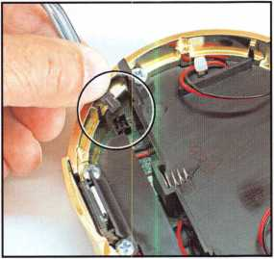

The lock cable is connected to the recep­tacle on the underside of the keypad. As with all S&G electronic locks, the connec­tor has offset ridges that align with slots in the receptacle. This ensures the cable connector is oriented correctly.

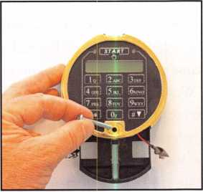

With the keypad mounted on the base, loosely install the long screw as shown. Do not tighten it until you have attached the batteries to the connectors and pushed the battery box into the keypad. After the screw is tightened, the self-stick S&G logo can be installed over the screw head.

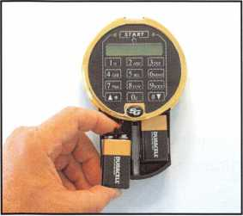

Battery replacement is simple. Just pull down on the battery box, remove the old batteries from the connectors, clip on new batteries, then push the box back up into the keypad housing.

Keynotes • March 2006

Pick the Best!

The Associated Locksmiths of America Offers You Invaluable Resources

ALOA is excited about the things planned for 2006. To celebrate our 50th anniversary this membership campaign features more benefits than ever.

* Education Discounts
* Automatic Entry into a drawing for a Key Machine
* Up to $300.00 savings on ALOA 2006 Anniversary convention registration.
* A free $10,000.00 bond (Active members only)
* New members receive immediate access to thou­sands of keycodes with a free trial membership to Blackhawk Products.
* ALOA store with books & merchandise
* A 10% discount for any bookstore purchase
* Celebrating 50 years in the security industry
* Referral Service
* Professional Publication - Keynotes

ALOA offers you the strength of over 8,000 leading firms and individuals. We are able to open many doors leading to the recognition, information, productivity and perspective needed for success in our ever-changing industry.

ALOA is your voice in the industry. It speaks for your concerns, your needs and your strengths. ALOA represents the collective interests of the association before the press, government, and the public.

ALOA Gives YOU:

Industry News and Information  
Publications and Public Relations

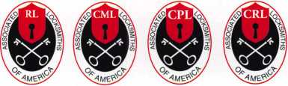

Professional Certification

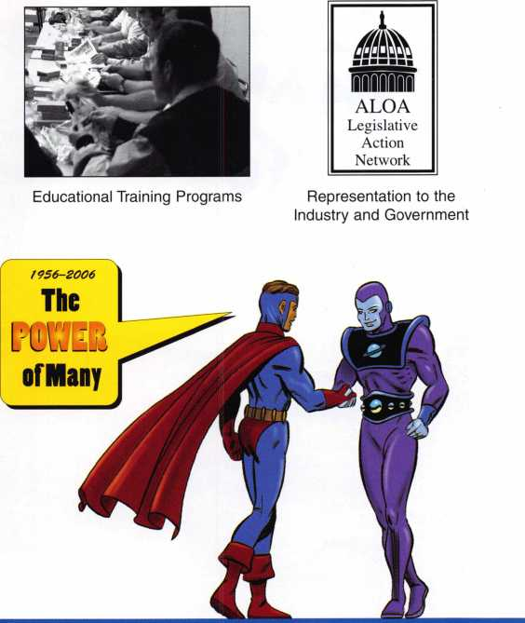

^IVERSA^

The ALOA Convention and Security Expo, held annually, is an important event for locksmiths, manufacturers, and distributors. Here, you can learn from professional speakers, discuss needs with suppliers and seek solutions with fellow members and participants.

***Come celebrate 50 years of Excellence at the ALOA 2006 Convention A Security Expo in fabulous Las Vegas, NV, July 8-16.***

ALOA’s Convention and Trade Show

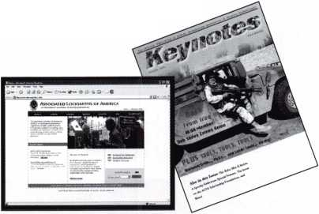

Customer Appreciation Daze

By: Claire L. Cohen, CML



Every one of us buys products and services on a daily weekly, monthly, or annual basis.

How many times in the last three to six months have you received some form of appreciation from those companies for the business you have given them? Unfortunately, the answer is often none! In this high- tech and fast-paced business environment, showing appreciation to customers is a dying practice. Yet, as consumers, we want to feel the companies we patronize value our business.

Most companies have a business plan to keep headed in the right direction. Some have a marketing plan to increase sales and attract new customers. Very few have a customer appreciation plan to reward those loyal cus­tomers who use their products and/or services. If your customers are your most important asset, what steps do you take to protect that asset? How much have you invested to let your customers know how much you value their business and their loyalty? In the security industry, this is just as important as any other type of business.

To eliminate daze and confusion on this subject, the goal should be to demonstrate to your customers how important they really are to our business.

We can learn from advertising and marketing profes­sionals, who make us very much aware of each holiday of the year. We can take some time to create our own “holiday” or event to tell our customers that we appreci­ate their business. This may be in the form of a “Customer Appreciation” day, week or month, as well as a daily practice.

Keynotes • March 2006

Before implementing a plan, every member of the staff must understand that it costs more to acquire a new cus­tomer than it does to retain an existing one. Educate all staff so that they understand the importance keeping exist­ing customers coming back.

Pick a time period. Create a day, week or month campaign to recognize loyal customers. Maybe it is your slowest time of the year. This may stimulate some business, also!

Send an e-mail, post card or put in your advertising that you invite past customers to come in for a special discount, a drawing or some refreshments. Even if they don’t come, you have had the opportunity to say thank you and let them know you appreciate their business

A small incentive or gift may inexpensively demonstrate your appreciation. Promote a gift with purchase. Possibly your supplier has give-away or promotional items. You may also opt to have some small item customized for your business. Another suggestion would be a “buy one, get one free” offer. Perhaps buy a padlock, get second item of equal value at a percentage off.

Send past customers an announcement of a new product which may be well suited to their needs. Better yet, see if you can encourage one of your vendors to co-sponsor it. Something as simple as a free sample or customized litera­ture can go a long way toward making your customers aware that you value their business.

Send a frequent purchaser card that rewards more loyalty along with a thank you note. Offer free delivery or a dis­count off a service call. For larger commercial/industrial customers, you may want to give them a thank-you gift.

Be sure to think visual and longevity. An imprinted gift will stay around as a mini billboard. Give t-shirts to cus­tomers. They are walking billboards that will promote your company for months to come. Send a card: “You are special and we appreciate your business!” Hand-addressed, rather than computer generated may have more impact.

Is Customer Appreciation Alive and Well at Your Company? Owners and managers may fall short in train­ing their staff on the customer-service aspect of their jobs.

This leaves employees lacking the skills they need to create a good customer-service experience for the consumer and it leaves customers feeling unappreciated.

Now is the time for customer appreciation to become a top priority. Remember the five most important words:

“thank you for your business!” Most customers would probably agree that they seldom hear those words. If you sell your product or service by phone, it is even more important to take that extra three seconds to sincerely say "thank you."

Don’t be in a “daze”. Demonstrate customer apprecia­tion—and don’t forget fellow employees and vendors. Although you may have acknowledged them during the year, you can really say thank you again and again. We all like to be appreciated. Customer appreciation is vital to the development of a loyal customer base. It's absolutely criti­cal. Don't lose another customer because they think you don’t care. Customers are your life blood. Tell your cus­tomers every day that you do care about them and appreci­ate their business. They might just keep coming back!

And by the way, “thank you” for reading my articles for the past 20 years. I enjoy writing for Keynotes Magazine and hope to continue !

Keynotes • March 2006

**33**

Email: [glmperry@iwuisp.com](mailto:glmperry@iwuisp.com) for unlock code ®GregPerry2003



SafeData

**Greg Perry, CML, CPS**

Open up your library! SafeData allows you to find the information you've  
invested in, fast.This one program has over 8500 listings of magazine, books,  
ClearStar Security Network posts and my personal library. Each listing includes not  
only the book or magazine, the issue, the title, the author and the page, but it also  
lists the lock and the hand of the lock (when available). SafeData lists patent dates  
and other trivia that may help in identifying a container or lock.

SafeData also has picture folders representing over 90 different manufactures of  
safes and locks with over a thousand pictures. Some models include a text file giv-  
ing general information on size and relock locations. Plus you can add your own  
information and update it yourself or purchase the annual updates.

SafeData is available exclusively from ALOA. Normal price for this CD is $249.95.  
Price includes two installs! Put it on your desktop and your laptop.

Special Introductory offer

includes your first update!

**$**199.95

To order contact ALOA (800) 532-2562

**RING of a KING**

|  |  |
| --- | --- |
| Member Name | Sponships |
| Kwok-kei Leung | 220 |
| Henry W. Raymond | 91 |
| Yuriko Yanai | 82 |
| Mary S. Ohmit CPL | 66 |
| Charles C. Robertson CML | 65 |
| William Lee CRL | 62 |
| Jack Hobin CPL | 51 |
| Clifford D. Lipscomb CML, CPS. | 51 |
| Michael B. Groves | 47 |
| C Allan Halverson | 40 |
| David M. Troiano | 51 |
| Myeong-Rae Cho | 38 |
| Jim Williams CRL | 40 |
| David M. Lowell CML, CMST | 36 |
| Salvatore J. Dulcamara CML | 36 |
| Dana L. Barnum CML | 35 |
| Barry K. Leas CRL | 35 |
| Danny W. Rudd CPL | 31 |
| Larry A. Warnick CML | 31 |
| Eugene R. Altobella Sr | 31 |
| Jeanne G. Lodge CML | 30 |
| Robert D. DeWeese CML | 30 |
| Scott L. Henke CPL, CPS | 29 |
| Dallas C. Brooks | 28 |
| Breck H. Camp CML | 27 |
| Lawrence F. Smith Jr, CML | 27 |
| John C. Elliott Jr, CML, CPS | 28 |
| Marian M. Swann CRL | 27 |
| James M. Watt CML, CPS | 26 |
| Robert W. Duman Sr, CML | 29 |
| William L. Young CML, CPS | 33 |
| Anthony J. Ramunno CML, CPS. | 24 |
| Jeffrey S. Nunberg CML, CMST. | 26 |
| J Thomas Hood CML | 26 |
| Ken Dale | 26 |
| Robert H. Stafford CML | 25 |
| Philip A. Rovenolt CPL | 25 |
| William T. Beranek | 29 |
| John L. Shandy CML | 25 |
| Elvis D. Hammerschmidt CPL | 25 |
| Jerome L. Cohen CML | 22 |
| Peter K. Gauthier CPL, CPS | 22 |
| Man-Soo Seo RL | 23 |
| James J. Cawby CML, CPS | 22 |
| James L. Hancock CPL | 27 |
| Hans Mejlshede CML | 25 |
| John S. Dorsey CML, CPS | 20 |
| Thomas G. Vandersteen CML, CPS.. 19 | |
| Peter Sarailian CRL | 23 |
| Walter W. Lascar RL | 18 |
| Keizo Takahashi CRL | 18 |
| James E. Fowler Sr, CML | 18 |
| David C. Harris CML | 18 |
| Ronald E. Heidzig | 18 |
| Joe J. Lee CRL | 18 |
| Takashi Kuwana CRL | 19 |
| Eugene R. Altobella Jr | 17 |
| Ernest W. Wright | 18 |

Peter R. Hall 17

William P. Grant CRL 20

James E. Gruber CPL 18

Evelyn V. Wersonick CML, CPS 15

Joseph P. Ferrero CML 15

Gary F. Teams CPL 14

Kenneth E. Kim CRL, CPS 16

William J. McElheney CML 1 8

John W. Soderland CML, CMST 15

Michael E. Jordan Jr, CML 15

Jon B. Griswold CML 16

Brian J. Reetz 15

John A. Ilk CRL, CPS 16

Russell P. Fuller CRL 16

Robert C. Rodocker CPL 13

John J. Greenan CML, CPS 15

Steve L. Cothron 15

Leonard J. Passarello CPL 14

Bruce J. Tarbet CML, CPS 12

John D. Cannon CML 14

Paul M. Souber 14

James T. Brickler CPL 14

Calvin G. Harris CML 13

Frank D. Hartung CML 13

Rolando Bouza 13

John F. Engel CRL 14

Richard C. Sievers 14

Brooke P. Berry CRL 13

William J. Wickward CML 12

Raymond C. Lusk CML 10

Robert M. Massard CRL, AHC 12

Gregory L. Perry CML, CPS 14

Eric F. Veal 12

Barry L. McMenimon CRL 1 2

Thomas J. Demont CML, AHC 11

Basil W. Shannon CPL 12

Ralph O. Warren CML 10

Gordon R. Racine CML 11

Kevin R. Wilson CML, CPS 11

Timothy K. Chow 10

Dale L. Knowles CPL 11

Timothy J. Moore CRL 13

Andrew A. Edmunds CML, CPS 1 1

Daniel S. Enriquez CRL 1 1

Gene Eldridge CPL 10

Ronald P. Riggins CML 11

Charles E. Haas CML 10

Robert E. Mock 12

Lester S. Brodsky 10

Larry L. Votaw CML 10

Thomas R. Smith CPL 10

Todd K. Ladwig CML, CPS 10

William T. Straub CML 10

Randy L. Hutchison CRL 10

Richard T. Johnson CPL 10

Vincent L. Formon CML, CPS 10

Carroll T. Croson Jr 10

Marian E. Sagar 10

Andrew S. Dennison CPL, CPS 10

How can I join the President's Club?

You can earn a membership in this prestigious club by recruiting  
just 10 new members for ALOA.

*Any ALOA member may participate.

What do I get?

When you recruit 10 members, you receive a  
handsome blue blazer with a President's Club crest.  
For each additional five members you recruit, you  
receive a lapel pin with gold-filled numbers, indicating,  
your recruiting successes.

You also get the satisifaction of knowing that you are  
helping your association, helping your industry grow,  
and you are helping fellow locksmiths achieve success.

How do I get started?

Mail the form below to the ALOA office for a supply of  
applications (800) 532-ALOA or FAX (214) 819-9736.  
One President's Club credit is awarded for each new  
applicant. Credit is awarded only after the membership  
application is pproved. However, the credit will apply  
for the period in which the application is received.  
Failure to identify yourself as the sponsor on the applica-  
tion form at the time it is submitted to ALOA for process-  
ing will forfeit any credit.

Yes! I want to join the ALOA Presidents Club.

Please rush me applications so I can start earning credit toward membership in the club!

Company

Address

City

Zip

Mail this form to ALOA • 3500 Easy St. • Dallas, Texas 75247-6416

**Classifieds**

EMPLOYMENT

EXPERIENCED LOCKSMITH WANTED

Charlottesville, VA is seeking an experienced locksmith. For informa­tion, please e-mail: [snowderrow@aol.com](mailto:snowderrow@aol.com) or fax resume to 434-971-8021. Phone 434-977-5397.

EXPERIENCED LOCKSMITH WANTED

Nationwide Security & Building Services, Inc. (NSBS) has been in business for over 30 years and is an established leader in the securi­ty industry. In addition to providing all aspects of locksmith and securi­ty services, we also provide com­plete facility maintenance. We are in need of experienced and moti­vated locksmiths who take pride in their work. We currently have an opening for a locksmith technician working out of our Downey, CA, San Diego, CA, Phoenix, AZ and Irving, TX locations. A qualified candidate must have minimum 2 years commercial locksmith experi­ence, excellent communication skills, a good driving record and some computer skills. Safe open­ing, skills in electrical, lighting, dry- wall, doors and gates are a plus. Benefits of being employed by NSBS include: paid vacation / hol­idays, medical, dental and life

insurance, competitive wages,

401 k plan, company truck and all tools are supplied, fun atmosphere with career growth. If you feel you are qualified and are looking for a challenging and rewarding compa­ny to work for, e-mail your resume to [dawnu@nsbs.net](mailto:dawnu@nsbs.net) or fax to (562) 299-1511.

WANTED

BVI, Inc., a Red Hawk Industries Company is seeking several exp. F/T Field Service Techs in MD, DC and VA. Must be exp. in physical and electronic security systems, or gen. bank equipment. Must have 3 + years exp. clean driving record, and pass a drug test. Excellent comp, and benefits pkg. inch com­pany vehicle. Forward resume with salary history to: [Resumes.PA@red- hawkindustries.com](mailto:Resumes.PA@red-hawkindustries.com) or fax to Linda Foggie at 215-396-8799.

STORE MANAGER WANTED

Opportunity in South Orange County, California for person with extensive locksmith and/or distribu­tor experience. Position provides salary, helath insurance, vacation and holidays. Send resume to: 949-492-0246 or call Tony's Locksmith at 949-492-5731.

LOCKSMITH WANTED

$3670.81-$4461.90 per month. The City of Chula Vista (San Diego's County second largest city) is currently seeking to fill their Locksmith position that will plan, implement and mainitain a master lock and key program including computer based acccess control systems throughout the city build­ings. This position has full benefits and will receive 1 6% COLA increase over the next four years. City of ChulaVista, 276 4th Ave, Ca. 91910 [www.chulavistaca.gov](http://www.chulavistaca.gov) or 619-691-5096 for more info. Apply immediately!

WANTED TO BlUY/SELL

FOR SALE

Framon II code machine, never used. Asking $1,500.00. Telephone: 610-698-8040,

Email: [Foxlocknkey@aol.com](mailto:Foxlocknkey@aol.com)

MOBILE LOCKSMITH BUSINESS FOR SALE

Central California Locksmith Business established in 1999 and still growing. Includes van, tools, equipment, code machine, invento­ry. Commercial, residential and automotive accounts. Located in Fresno, CA. $50,000. Ask for Noa Kristi 559-447-5397

KEY MACHINES FOR SALE

HPC 1200, Abloy, KD-55 High Security, Fitmaster, Curtis Automatic #2000, Scotsman #747-X, Sager #500, Borkey #954-2, llco Duplicon #2585, Keil #6 1/2, Segal #815, Belsaw, 2 Schlage double-sided key punches. Phone Jerry at 208-461-4606 or email: [mariemeilan@yc2.net](mailto:mariemeilan@yc2.net)

NEW LOCKSMITH SHOP FOR SALE

Leased store front shop. Would like to retire due to health. Next to NASA Bay Space Center, on a very busy highway. Covering three counties. Over $70,000 plus in equipment and inventory. Fully equipped van. Asking $55,000, will consider all reasonable offers. Email if interested

[www.fgarza](http://www.fgarza) [1948@yahoo.com](mailto:1948@yahoo.com) or fax 281-488-0883.

BUSINESS FOR SALE

Ideal business for 1 person or easi­ly expand business. Established 1997 - mostly commercial and resi­dential. Repeat and referral busi­ness with $0 paid advertising, close proximity accounts (about 8K miles per year), bankers hours (M-F 9-5, Sat 9-3). Shop equipment, tools and inventory, 2003 truck (less than 50K miles) with equip­ment, tools, and inventory. Deal on shop lease if desired or run as a mobile business. Asking $150K - annual gross sales over 100K -

annual net profit well over 50K. Located in Houston, TX. Call Ron 281-660-3000.

BUSINESS FOR SALE

Turn key lock shop business, over 20 years same location. In the most enchanting and diverse region on Earth. Port Angeles, Wa. where the Olympic Mountains meet the Sea. $170,000 Includes all equipment, inventory, tools, cus­tomer list and training. Call Harriet at Windermere Real Estate 1-800- 786-1456 ext. 30

BUSINESS FOR SALE

In south-central Wisconsin, well- established,^ years in the same location. One person shop with room to expand.Business has many commercial and residential accounts. Includes service van,equipment,and invento- ry.$85,000 takes all. Owner wish­es to retire-will help with transition. CALL (608)325-5011 OR EMAIL: [lockshop@tds.net](mailto:lockshop@tds.net)

SAAALL MOBILE LOCKSMITH BUSINESS FOR SALE

Established 1979 with solid client base. Excellent opportunity for someone who is wanting to relo­cate and start a business. Located in sunny Albuquerque, NM. We're ready to retire!!!

Commercial Safe & Lock 475-58th St. NW Albuquerque, NM 87105 505-836-9503

FOR SALE

Locksmith equipment and inventory. Machines, keys, locks, tools - all for one low price - due to health, must sell. ALOA member. Forest E. Long, 970-854-3301

WANTED TO BUY

Want to purchase old and dis- countinued Schlage Decorative Hardware in both Dragon and La Fontaine designs. Any assistance would be gladly welcome. ALOA member. Peter Field, P.O. Box 104, Salem, VA, 24153. Tel. 540- 380-5000. Fax. 540-380-1657.

Classified Advertising Policy

Classified advertising space is provided free of charge to ALOA members and for a fee of $2.00 per word, $40.00 minimum for non members. Classified ads may be used to advertise used merchandise and overstocked items for sale, "wanted to buy" items**,** business opportunities, employment opportunities/positions wanted and the like. Members or non members wishing to advertise services or new merchandise for sale may purchase a "Commercial Classified Ad" for a fee of $4.00 per word with a minimum of $100.00. Each ad will run for two issues. For blind boxes there is a $10.00 charge for members and non members. All ads must be submitted in writing to the Advertising Sales Department via fax at 817-645-7599 or through an email to [adsales@aloa.org](mailto:adsales@aloa.org) by the fifteenth of the month two months prior to issue date. ALOA reserves the right to refuse any classified adver­tisement that it deems inappropriate according to the stated purpose of the classified advertising section.

1

|  |  |
| --- | --- |
| a s s o c i a t | e |
| members |  |

Distributor

**1st in Hardware, Inc.**

Phone: Phone: 410-646-9900 Fax: 410-646-0045 www. 1 stinhardware.com

**Accredited Lock Supply Co.**

Phone: 800-652-2835 Fax: 201-865-2435 [www.acclock.com](http://www.acclock.com)

**Andrews Wholesale Lock Supply**

Phone: 717-272-7422 Fax: 717-274-8659 [www.andrewslock.com](http://www.andrewslock.com)

**Boyle & Chase Inc.**

Phone: 800-325-2530 Fax: 800-205-3500 [www.boyleandchase.com](http://www.boyleandchase.com)

**Clark Security Products**

Phone: 888-784-1311 Fax: 619-718-7333 [www.clarksecurity.com](http://www.clarksecurity.com)

**Cook's Building Specialties**

Phone: 505-883-5701 Fax: 505-883-5704

**Dire's Lock & Key Company**

Phone: 303-294-0176 Fax: 303-294-0198

**Direct Security Supply, Inc.**

Phone: 800-252-5757 Fax: 800-452-8600

**Discount Key Machines.Com/Busch**

Phone: 800-332-8724 Fax: 407-363-4666

**Doyle Security Products**

Phone: 800-333-6953 Fax: 612-521-0166 [www.doylesecurity.com](http://www.doylesecurity.com)

**Dugmore and Duncan, Inc.**

Phone: 888-384-6673 Fax: 888-329-3846

**E. L. Reinhardt Co., Inc.**

Phone: 800-328-1311 Fax: 651-481-0166 [www.elreinhardt.com](http://www.elreinhardt.com)

**Ewert Wholesale Hardware**

Phone: 800-451-0200 Fax: 708-597-0881

**Foley-Belsaw Company**

Phone: 800-821-3452 Fax: 816-483-5010 [www.foley-belsaw.com](http://www.foley-belsaw.com)

**Fried Brothers Inc.**

Phone: 800-523-2924 Fax: 215-592-1255 [www.fbisecurity.com](http://www.fbisecurity.com)

**H.L. Flake Co.**

Phone: 800-231-4105 Fax: 713-926-3399 [www.hlflake.com](http://www.hlflake.com)

**Hans Johnsen Company**

Phone: 214-879-1550 Fax: 214-879-1530 [www.hjc.com](http://www.hjc.com)

**Hardware Agencies, Ltd.**

Phone: 416-462-1921 Fax: 416-462-1922 [www.hardwareagencies.com](http://www.hardwareagencies.com)

**IDN Incorporated**

Phone: 817-421-5470 Fax: 817-421-5468 [www.idn-inc.com](http://www.idn-inc.com)

**Instant Hardware Delivery, Inc**

Phone: 800-355-1 107 Fax: 800-663-8518

**Intermountain Lock & Supply**

Phone: 800-453-5386 Fax: 801-485-7205 [www.intermountainlock.com](http://www.intermountainlock.com)

**International Electronics, Inc**

Phone: 800-343-9502 Fax: 617-821-4443

**Jo Van Distributors**

Phone: 416-288-6306 Fax: 416-752-8371 [www.jovanlock.com](http://www.jovanlock.com)

**Lockmasters, Inc.**

Phone: 859-885-6041 Fax: 859-885-7093 [www.lockmasters.com](http://www.lockmasters.com)

**Locks Company**

Phone: 800-288-0801 Fax: 305-949-3619

**Locksmith Ledger international**

Phone: 847-454-2700 Fax: 847-454-2759 [www.lledger.com](http://www.lledger.com)

**McDonald Dash Locksmith Supply**

Phone: 800-238-7541 Fax: 901-366-0005 [www.mcdonalddash.com](http://www.mcdonalddash.com)

**Monaco Lock Co.**

Phone: 800-526-6094 Fax: 800-845-5625 [www.monacolock.com](http://www.monacolock.com)

**Omaha Wholesale Hardware**

Phone: 800-238-4566 Fax: 402-444-1664 [www.omahawh.com](http://www.omahawh.com)

**Phoenix Safe international LLC**

Phone: 765-483-0954 Fax: 765-483-0962 [www.phoenixsafeusa.com](http://www.phoenixsafeusa.com)

**Positive Identity Solutions**

Phone: 704-663-1175 Fax: 704-660-1301 [www.pids-usa.com](http://www.pids-usa.com)

**RA-Lock Company**

Phone: 972-775-6301 Fax: 972-775-6316 [www.ralock.com](http://www.ralock.com)

**Security Distributors Inc**

Phone: 800-333-6953 Fax: 612-524-0166

**Security House**

Phone: 905-669-5300 Fax: 905-660-6313 [www.securityhouselock.com](http://www.securityhouselock.com)

**Security Lock Distributors**

Phone: 800-847-5625

Fax: 800-878-6400

www. sec u r i ty loc kd i stri b u to rs. co m

**Southern Lock and Supply Co.**

Phone: 727-541-5536 Fax: 727-544-8278 [www.southernlock.com](http://www.southernlock.com)

**Stone & Berg Wholesale**

Phone: 800-225-7405 Fax: 800-535-5625

**The Locksmith Store Inc.**

Phone: 847-364-5111 Fax: 847-364-5125 [www.locksmithstore.com](http://www.locksmithstore.com)

**Timemaster Inc.**

Phone: 859-259-1878 Fax: 859-255-0298 [www.time-master.com](http://www.time-master.com)

**Top Notch Distributors, Inc.**

Phone: 800-233-4210 Fax: 800-854-4146 [www.topnotch.bz](http://www.topnotch.bz)

**Turn 10 Wholesale**

Phone: 800-848-9790 Fax: 800-391-4553

**U.S. Lock Corp.**

Phone: 800-925-5000 Fax: 800-338-5625 [www.uslock.com](http://www.uslock.com)

**Wilson Safe Company**

Phone: 215-492-7100 Fax: 215-492-7104 [www.wilsonsafe.com](http://www.wilsonsafe.com)

Manufacturer

**A & B Safe Corporation**

Phone: 800-253-1267 Fax: 856-863-1208 [www.a-bsafecorp.com](http://www.a-bsafecorp.com)

**ABUS Lock Company**

Phone: 800-352-2287 Fax: 602-516-9934 [www.abus.com](http://www.abus.com)

**Access Security Products Ltd.**

Phone: 905-337-7874 Fax: 905-337-7873 [www.access-safe.com](http://www.access-safe.com)

**Adams Rite Mfg Company**

Phone: 800-872-3267 Fax: 800-232-7329 [www.adamsrite.com](http://www.adamsrite.com)

**Adesco Safe Mfg. Company**

Phone: 800-694-9340 Fax: 562-408-6427 [www.adesco.com](http://www.adesco.com)

**Adrian Steel Company**

Phone: 800-677-2726 Fax: 517-265-5834 [www.adriansteel.com](http://www.adriansteel.com)

**Advanced Diagnostics USA Inc**

Phone: 650-876-2020 Fax: 650-876-2022 [www.ad-mvp.com](http://www.ad-mvp.com)

**All Five Tool Company, Inc.**

Phone: 860-583-1691 Fax: 860-583-4516 [www.all5tool.com](http://www.all5tool.com)

**American Security Products**

Phone: 909-685-9680x2013 Fax: 909-685-9685 [www.amsecusa.com](http://www.amsecusa.com)

**BWD Lockcraft**

Phone: 973-728-3707 Fax: 973-728-3731 [www.bwdautomotive.com](http://www.bwdautomotive.com)

**Bianchi USA, Inc.**

Phone: 800-891-2118 Fax: 216-803-0202 [www.bianchi](http://www.bianchi) 1770usa.com

**Buddy Products**

Phone: 312-733-6400 Fax: 312-733-8356

[www.buddyproducts.com](http://www.buddyproducts.com)

Keynotes • March 2006



associate

**members**

**CCL Security Products**

Phone: 800-733-8588 Fax: 847-537-1800 [www.cclsecurity.com](http://www.cclsecurity.com)

**CompX Security Products**

Phone: 864-297-6655 Fax: 864-297-9987 [www.compxnet.com](http://www.compxnet.com)

D&D Technologies (USA), Inc. Phone: 714-677-1300x292 Fax: 714-677-1299 [www.ddtechusa.com](http://www.ddtechusa.com)

**DETEX Corp.**

Phone: 800-729-3839 Fax: 830-620-6711 [www.detex.com](http://www.detex.com)

**Don-Jo Manufacturing, Inc.**

Phone: 978-422-3377 Fax: 978-422-3467 [www.don-jo.com](http://www.don-jo.com)

**Door Controls International**

Phone: 800-742-3634 Fax: 800-742-0410 [www.doorcontrols.com](http://www.doorcontrols.com)

**Doorking Inc.**

Phone: 800-826-7493 Fax: 310-641-1586 [www.doorking.com](http://www.doorking.com)

**FireKing Security Products**

Phone: 800-457-2424 Fax: 800-896-6606 [www.fkisecuritygroup.com](http://www.fkisecuritygroup.com)

**Framon Manufacturing Company Inc.**

Phone: 989-354-5623 Fax: 989-354-4238 [www.framon.com](http://www.framon.com)

**HY-KO Products Co.**

Phone: 330-467-7446 Fax: 330-467-7442

**Hammerhead Industries, Inc.**

Phone: 805-658-9922 Fax: 805-658-8833 [www.gearkeeper.com](http://www.gearkeeper.com)

**Ingersoll Rand Security Technologies**

Phone: 317-805-5713 Fax: 317-805-5779 [www.schlagelock.com](http://www.schlagelock.com)

**Jackson Corporation**

Phone: 323-269-81 1 1 Fax: 800-888-6855 [www.jacksonexit.com](http://www.jacksonexit.com)

**Jet Hardware Mfg., Co.**

Phone: 718-257-9600 Fax: 718-257-0973 [www.jetkeys.com](http://www.jetkeys.com)

**KABA ILCO Corp.**

Phone: 252-446-3321 Fax: 252-446-4702 [www.kaba-ilco.com](http://www.kaba-ilco.com)

**KEY-BAK/West Coast Chain Mfg.**

Phone: 909-923-7800 Fax: 909-923-0024 [www.keybak.com](http://www.keybak.com)

**Keri Systems Inc.**

Phone: 408-451-2520 Fax: 408-441-0309 [www.kerisys.com](http://www.kerisys.com)

**Knaack Manufacturing Co.**

Phone: 800-456-7865 Fax: 815-459-9097 [www.weatherguard.com](http://www.weatherguard.com)

**Kustom Key Inc.**

Phone: 800-537-5397 Fax: 800-235-4728 [www.kustomkey.com](http://www.kustomkey.com)

**LAB Security**

Phone: 800-243-8242 Fax: 860-583-7838 [www.labpins.com](http://www.labpins.com)

**La Gard Inc.**

Phone: 310-325-5670 Fax: 310-325-5615 [www.lagard.com](http://www.lagard.com)

**Lock America, Inc. dba L.A.I. Group**

Phone: 714-373-2993 Fax: 714-373-2998 [www.laigroup.com](http://www.laigroup.com)

**Lucky Line Products, Inc.**

Phone: 858-549-6699 Fax: 858-549-0949 [www.luckyline.com](http://www.luckyline.com)

**M.A.G. Manufacturing**

Phone: 714-891-5100 Fax: 714-892-6845 [www.magmanufacturing.com](http://www.magmanufacturing.com)

**MUL-T-LOCK USA, Inc.**

Phone: 800-562-3511 Fax: 973-778-4007 [www.mul-t-lockusa.com](http://www.mul-t-lockusa.com)

**Maxcess Card Systems Ltd**

Phone: 949-492-5964 Fax: 949-492-0415 [www.maxcess-card.com](http://www.maxcess-card.com)

**Medeco Security Locks**

Phone: 540-380-5000 Fax: 540-380-5010 [www.medeco.com](http://www.medeco.com)

**Mil-Comm Products Co Inc**

Phone: 201-935-8561 Fax: 201-935-6059

**Protex Safe Co., LLC**

Phone: 818-610-8030 Fax: 818-610-8004 [www.protexsafe.com](http://www.protexsafe.com) ROFU International Corp. Phone: 253-922-1828 Fax: 253-922-1728 [www.rofu.com](http://www.rofu.com)

**Rutherford Controls Int'l Co.**

Phone: 519-621-7651

Fax:519-621-7939

[www.rutherfordcontrols.com](http://www.rutherfordcontrols.com)

**STRATTEC Security Corp.**

Phone: 414-247-3333

Fax:414-247-3564

www. after ma rket. strattec .com

**Sargent & Greenleaf, Inc.**

Phone: 859-885-9411 Fax: 859-885-3063 [www.sargentandgreenleaf.com](http://www.sargentandgreenleaf.com)

**Sargent Manufacturing Co.**

Phone: 800-727-5477 Fax: 888-863-5054 [www.sargentlock.com](http://www.sargentlock.com)

**Schwab Carp.**

Phone: 765-447-9470 Fax: 765-447-8278 [www.schwabcorp.com](http://www.schwabcorp.com)

**Securifort Inc**

Phone: 819-359-2226 Fax: 819-359-2218 [www.securifort.com](http://www.securifort.com)

**Securitron Magnalock Corp.**

Phone: 775-355-5625 Fax: 775-355-5636 [www.securitron.com](http://www.securitron.com)

**Security Door Controls**

Phone: 805-494-0622 Fax: 805-494-8861 [www.sdcsecurity.com](http://www.sdcsecurity.com)

**Security Solutions**

Phone: 405-376-1600 Fax: 405-376-6870 [www.securitysolutions-usa.com](http://www.securitysolutions-usa.com)

**Townsteel, Inc.**

Phone: 626-858-5080 Fax: 626-858-3393 [www.townsteel.com](http://www.townsteel.com)

**UCA Inc**

Phone: 972-437-4696 Fax: 972-692-7056 [www.ibuttonlock.com](http://www.ibuttonlock.com)

**YSG Door Security Consultants, Inc.**

Phone: 800-438-1951 Fax: 800-338-0965

Service

Organization

**Allstate Insurance Company**

Phone: 847-551-2181 Fax: 847-551-2732 [www.allstate.com](http://www.allstate.com)

**Cardservice Mobile Solutions**

Phone: 561-210-8488 Fax: 561-953-6268 [www.cardservicems.com](http://www.cardservicems.com)

**Cross Country Automotive Services**

Phone: 800-541-2262 Fax: 781-393-0256 [www.argosi.com](http://www.argosi.com)

**Massglass & Door Service**

Phone: 888-742-8837 Fax: 805-497-2255 [www.massglass.com](http://www.massglass.com)

**The Mechanic Group Inc**

Phone: 845-735-0700 Fax: 845-735-8383 [www.mechanicgroup.com](http://www.mechanicgroup.com)

**Webster Safe & Lock Co., Inc.**

Phone: 901-332-2911 Fax: 901-332-2878 [www.webstersinc.com](http://www.webstersinc.com)

**Videx Inc.**

Phone: 541-758-0521 Fax: 541-752-5285 [www.videx.com](http://www.videx.com)

Keynotes • March 2006



JOIN ALOA'S LEGISLATIVE EFFORTS TODAY!!

Over 550 members from 44 states, Washington DC, Puerto Rico, and six countries currently partake in ALOA's Legislative Action Network (LAN). LAN members are our best resources at the grassroots level for effecting leg­islative change. They help ALOA monitor each state legislature for bills affecting the locksmithing profession, including related industries. They organize media contact which helps the public understand our profession. Members contact state legislators; organize letter writing campaigns; and keep everyone informed in state and regional locksmith associations. Members assist the national ALOA office with state fundraising campaigns in situations where our profession is faced with detrimental legislation and a lobbyist is deemed necessary to assure success.

A monetary contribution is not required to be involved in ALOA's legislative activities, just email Tim McMullen, Legislative Manager at [tim@aloa.org](mailto:tim@aloa.org) with your ALOA Member Number, and he will make sure you receive the quarterly Legislative Action Network Update alerting you to important legislation in your state and around the country.

If you contribute $100 or more to the Legislative Action Network (LAN), you become a member of the presti­gious Legislative Action Network (LAN) Council.

It's simple to join the LAN Council - log into the ALOA Store at > <http://www.aloa.org/store>. Click on Search and type in "Council". From there you can join at four different donor levels. Add this to your basket and checkout! Note: if this is the first time you have used the ALOA Store, you will need to set up a username and password.

The Council is an important tool in raising the standards of our profession through the legislative process by making sure that locksmiths have the final say in how our industry will be run. As a Council member, you will receive:

* The quarterly Legislative Action Network Update alerting you to important legislation in your state and

around the country.

* A comprehensive guide to lobbying in your state capital, so you can be the "voice of ALOA" to legislators.
* A lapel pin designating you as a special ALOA LAN Council member,
* Recognition in Keynotes magazine.
* Invitation to exclusive functions at the annual ALOA convention for LAN Council members.
* Complimentary Legislative Convention merchandise.

Let your voices be heard! Join LAN and the LAN Council today!

Keynotes • March 2006



ALABAMA S 359 AUTHOR: Smitherman (D)

TITLE: Relates To Alarm System Installers, To Provide For DISPOSITION: Pending SUMMARY:

Relates to alarm system installers, to rovide for the regulation of locksmiths y the Alabama □ectronic Security Board of Licensure.

STATUS:

* 01/26/2006 INTRODUCED.
* 01/26/2006 To SENATE Committee on GOVERNMENTAL AFFAIRS.

CALIFORNIA A 714 AUTHOR: Ridley-Thomas (D)

TITLE: Motor Vehicles: Key Information Access

DISPOSITION: Failed SUMMARY:

Requires a motor vehicle manufacturer of a motor vehicle sold or leased in the state after a specified date, with a cer­tain model year or later, to provide a means whereby the registered owner of that vehicle can access information, and only that information, that is neces­sary to permit the reproduction of a key or other functionally similar device, or the performance of any necessary service to allow for entrance, starting and operation of the vehicle.

STATUS:

* 02/17/2005 INTRODUCED.
* 09/07/2005 To ASSEMBLY Committees on TRANSPORTATION and BUSINESS AND PROFES­SIONS.
* 09/08/2005 From ASSEMBLY Committee on TRANSPORTATION with author's amendments.
* 09/08/2005 In ASSEMBLY. Read second time and amended. Re­referred to Committee on TRANS­PORTATION.
* 01/04/2006 From ASSEMBLY Committee on TRANSPORTATION with author's amendments.
* 01/04/2006 In ASSEMBLY. Read second time and amended. Re­referred to Committee on TRANS­PORTATION.
* 01/09/2006 From ASSEMBLY Committee on TRANSPORTATION: Do pass to Committee on BUSINESS AND PROFESSIONS.
* 01/12/2006 In ASSEMBLY Committee on BUSINESS AND PRO­FESSIONS: Heard, remains in Committee.
* 01/31/2006 From Committee: Filed with the Chief Clerk pursuant to JR 56. Died pur­suant to Art. IV, Sec. 10(c) of the Constitution.

IOWA HSB 507

SPONSOR: House Judiciary Committee TITLE: Locksmith DISPOSITION: Pending LOCATION: House Judiciary

Committee

Relates to a locksmith assisting a per­son in entering a residency and provid­ing a penalty.

STATUS:

* 01/10/2006 INTRODUCED.
* 01/10/2006 To HOUSE Committee on JUDICIARY.

ILLINOIS H 4616 SPONSOR: Saviano (R)

TITLE: Firearm Authorization Card DISPOSITION: Pending SUMMARY:

Amends the Private Detective, Private Alarm, Private Security, and Locksmith Act of 2004. Replaces references to firearm authorization card with firearm control card throughout the Act. Removes the provision that allows a person who meets certain qualifications to receive a license as a private alarm contractor without having passed the required examination. Provides that the Department may issue a temporary firearm control card.

STATUS:

* 01/12/2006 INTRODUCED.
* 01/12/2006 To HOUSE Committee on RULES.

ILLINOIS H 4715 SPONSOR: Kelly (D)

TITLE: Safe Homes Act DISPOSITION: Pending SUMMARY:

Creates the Safe Homes Act. Provides that a victim of domestic violence or sexual violence has certain rights with respect to the victim's dwelling unit. Provides that, depending upon the cir­cumstances, the victim can obtain relief that includes: requiring that the land­lord change the locks, allowing the vic­tim to change the locks if the landlord does not act, terminating the lease, and imposing penalties on a landlord for certain violations.

STATUS:

* 01/12/2006 INTRODUCED.
* 01/12/2006 To HOUSE Committee on RULES.
* 01/31/2006 To HOUSE Committee on HOUSING & URBAN DEVELOPMENT.

MARYLAND S 452 AUTHOR: Hooper (R)

TITLE: Vehicle Laws INTRODUCED: 02/02/2006 DISPOSITION: Pending SUMMARY:

Requires a vehicle manufacturer licensed in the State to implement, by January 1, 2008, a system to provide a registered owner or lessee or a speci­fied motor vehicle access to informa­tion sufficient to allow the reproduction of a key required to operate the motor

vehicle; requires a manufacturer to allow access to this information 24 hours per day and 7 days per week. STATUS:

* 02/02/2006 INTRODUCED.
* 02/02/2006 To SENATE Committee on JUDICIAL PROCEEDINGS.

MARYLAND H 50 AUTHOR: Goodwin (D)

TITLE: Business Income Tax Exemption for Security

INTRODUCED: 02/02/2006 DISPOSITION: Pending SUMMARY:

Allowing certain business entities a cer­tain credit against the State income tax for certain expenses incurred for cer­tain security devices and certain securi­ty guard services under certain circum­stances; limits to a certain amount the total amount of credits a business entity may claim in any calendar year; pro­vides that the credit may not exceed the State income tax for that taxable year and that any unused credit may not be carried over to any other tax­able year.

STATUS:

* 01/03/2006 PREFILED.
* 01/1 1/2006 INTRODUCED.
* 01/1 1/2006 To HOUSE Committee on WAYS AND MEANS.

MISSISSIPPI H 160 AUTHOR: Denny (R)

TITLE: Income Tax INTRODUCED: 02/02/2006 DISPOSITION: Pending SUMMARY:

Relates to income tax; provides credit for taxpayer paying home security expenses for primary residence. STATUS:

* 01/03/2006 INTRODUCED.
* 01/03/2006 To HOUSE Committee on WAYS AND MEANS.

MISSISSIPPI S 2484 AUTHOR: Jackson G (R)

TITLE: Alarm Contractors Licensing Act

DISPOSITION: Failed

SUMMARY:

Relates to the state Alarm Contractors Licensing Act.

STATUS:

* 01/12/2006 INTRODUCED.
* 01/12/2006 To SENATE Committee on BUSINESS AND FINANCIAL INSTITUTIONS.
* 01/31/2006 Died in committee.

OKLAHOMA S 1741 AUTHOR: Barrington (R)

TITLE: Professions And Occupations DISPOSITION: Failed SUMMARY:

Relates to professions and occupations; relate to the Alarm Industry Act; pro­vides short title; adds the locksmith industry to create the Alarm and Locksmith Industry Act; adds defini­tions; makes language gender neutral; provides exemptions; provides exemp­tion from certain Act; provides for the Alarm and Locksmith Industry Committee; modifies membership, experience and terms of the Committee; provides for powers and duties of the Committee.

STATUS:

* 01/20/2006 PREFILED.
* 02/06/2006 INTRODUCED.
* 02/07/2006 To SENATE Committee on BUSINESS AND LABOR.

VIRGINIAS 125 AUTHOR: O'Brien (R)

TITLE: Motor Vehicle Keys DISPOSITION: Pending SUMMARY:

Requires a means whereby the owners, lessees, and representatives of owners and lessees of such motor vehicles may obtain all information required to per­mit the reproduction of any key required to operate the owner's or lessee's vehicle.

STATUS:

* 01/11/2006 INTRODUCED.
* 01/11/2006 To SENATE Committee on TRANSPORTATION.

WASHINGTON S 6296 AUTHOR: Delvin (R)

TITLE: Alarm System Companies DISPOSITION: Pending SUMMARY:

Relates to alarm system companies and licensing of private security guards. STATUS:

* 01/10/2006 INTRODUCED.
* 01/10/2006 To SENATE Committee on LABOR, COMMERCE,

RESEARCH & DEVELOPMENT.

WEST VIRGINIA H 3177 AUTHOR: Talbott (D)

TITLE: Home Security System Installers DISPOSITION: Pending SUMMARY:

Requires that employers perform crimi­nal history background checks for employees involved in the installation of home security systems.

STATUS:

* 01/1 1/2006 INTRODUCED.
* 01/1 1/2006 To HOUSE Committee on JUDICIARY.



Keynotes • March 2006

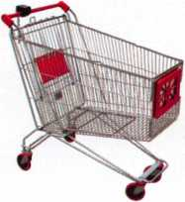

keynotes

Buyer's Marketplace

**Professional Business Products**

Invoices Tags *Call for a free*

Checks Key Fobs *brochure and samples*

**Business Magnets 1-800-355-6322**

Cards Labels [www.pbp2000.com](http://www.pbp2000.com)

CLAIM CHECK

VOUR FIRM NAME HERE

your tow*, state Am Zip

Ptwm 123-4507

N9 4321

IN-STOCK...MORE SAFES

***FREE Freight Program***

***(30 States)***

AMSEC FireKing

**BaM** HAYMAN MEIUNK y/CTOR

**TURD i©**

**WHOLESALE SERVICJE**

800**-**848-9790

ACCEPT CREDIT CARDS!

In your Locksmithing Business, Sto ref ro n ts/Off i ces/Homebased

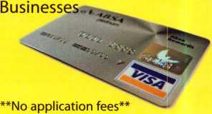

**No Monthly Minimum**

**No Lease Requirements**

**Onsite wireless terminals available**

RETRIEVER PAYMENT SYSTEMS

888**-**549-6424

Keynotes • March 2006

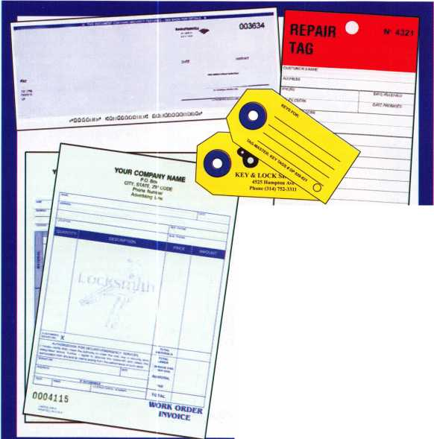

Part No. 708884

|  |  |  |
| --- | --- | --- |
|  | CODE-SEEKER | ,?Ua=3i |
| wm JsKmsSr - | 0GD GD |  |
| Xfv, ^I=i|pr ^ !■§ | 00®  0®®  ®00 | Jr. |
| ! |  |
| Start something. | ffi®0 | !' |

It's everything you need to crack the vast transponder market.

The right tool. The right codes. The right company. The endless opportunity. So get started. Now. Here.



**STRATTEC"**

TRUSTED SOURCE. MANY SOLUTIONS.

Call 877-251 -8798 or visit us at <http://aftermarket.strattec.com> © 2005 strattec security corporation

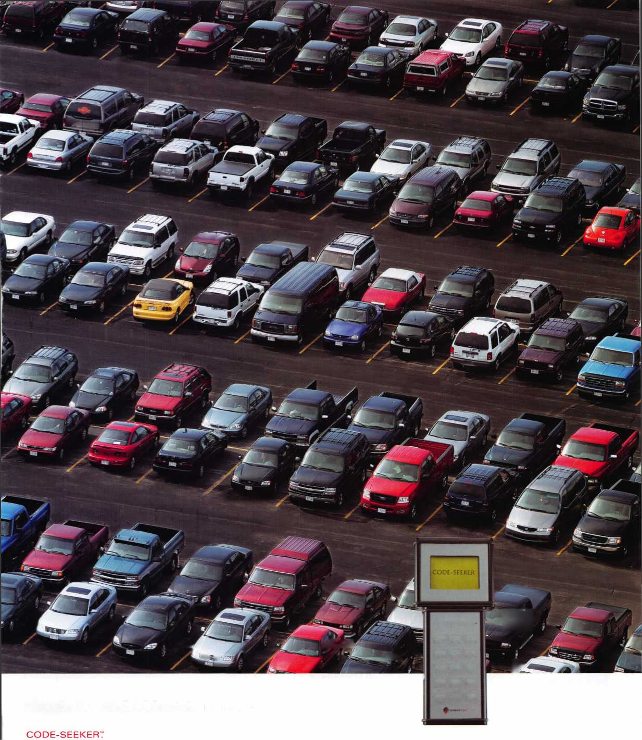

The Master Locksmiths  
Association Of New Jersey

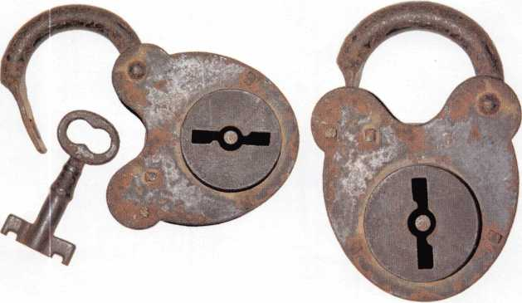

2006

East Coast Regional  
Lock & Security Show

(Classes, Trade Show, and Banquet)

March 16th thru March 19th

Crowne Plaza Meadowlands Hotel  
2 Harmon Drive  
Secaucus, NJ 07094

For more information:

P.O. Box 2441

Morristown, NJ 07962-2441  
Fax 973-538-1588 or visit [www.MLANJ.org](http://www.MLANJ.org)

We represent the 500 employees of CompX Security Products.

Hardworking. Reliable. Dedicated.

And it shows in the products we make.

Is it any surprise that, year after year, you the locksmith community, choose to partner with us?

Made in America does matter to you, and it matters to us. Through our four US facilities, we will continue to provide you with the high quality products you have come to expect from CompX Security Products.

J

Shirley, 23 year

Lock Assembly

*Connat*

*Cbm*®C

CO/77/%

**Cbm/X**

Alberto, 11 years Machine Operator

Raymond, 4 years Accounting

*CbmM*

SECURITY PRODUCTS

y, 8 years tomer Service

NATIONAL

FORT TIMBERLINE

CHICAGO

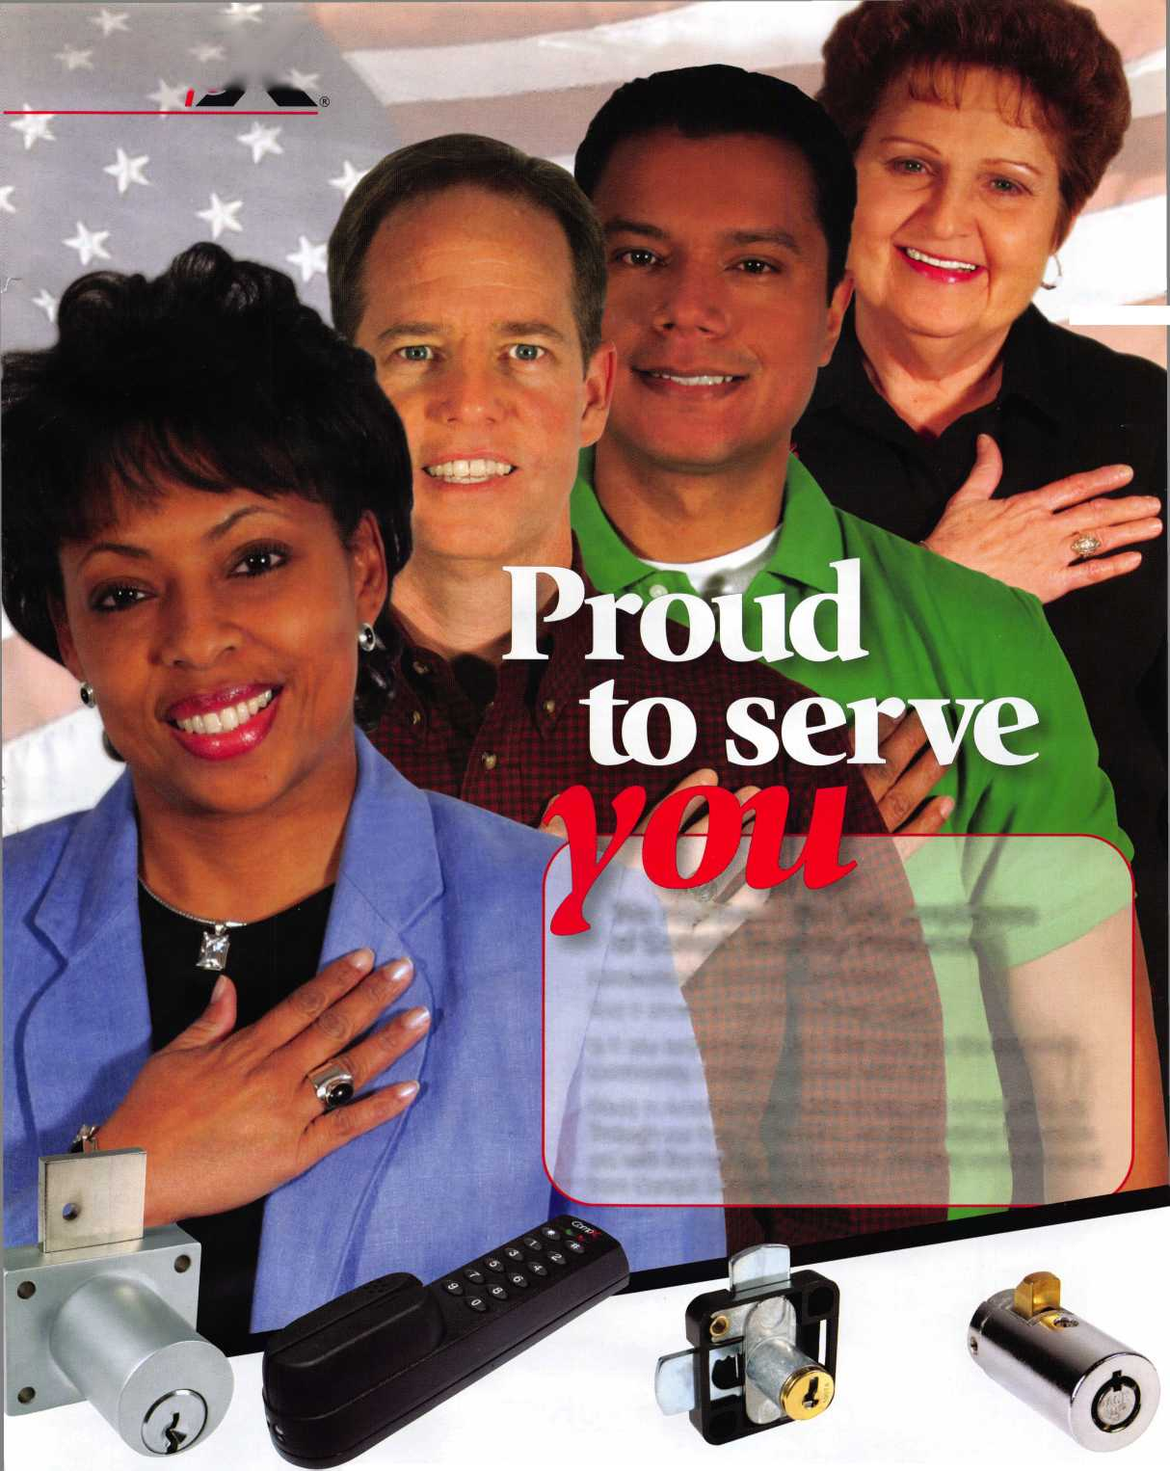

I

ADESCO FlREKlNG/GARY MEILINK

c/OR SAFES THAT FIT EVERY NEED AND BUDGET, COUNT ON THE TRUSTED BRANDS OF FlREKlNG® SECURITY GROUP. ADESCO® OFFERS SAFES FOR GOVERNMENT, COMMERCIAL AND RESIDENTIAL CUSTOMERS. MEILINK® PROVIDES FIRE- AND BURGLARY-RATED SAFES FOR BANKS, SCHOOLS AND RETAIL ESTABLISHMENTS. AND FlREKlNG FEATURES UL®-RATED FIRE/ IMPACT/BURGLARY RESISTANT SAFES BACKED BY OVER 50 YEARS OF SECURITY EXPERIENCE. PLUS, EACH BRAND COMES WITH EXCLUSIVE 24/7/365 TECHNICAL SUPPORT. SO FIND OUT MORE ABOUT FlREKlNG SECURITY GROUP. YOUR CUSTOMERS TRUST YOU TO RECOMMEND THE BEST. TRUST US TO PROVIDE IT.

Fire King

QFn irity nnni

SECURITY GROUP

[www.fireking.com](http://www.fireking.com)

